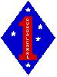 The 1st Marine Division Association-Silicon Valley Chapter
Is Hosting the
3rd Annual SOS Breakfast
On 28 October 2017
Come to the Moffett Field Museum
From 10:00 to Noon
All Marines and Corpsmen welcome
Bring a Buddy or Spouse
SOS on toast, juice, fresh fruit and coffee-Donations Welcome
RSVP by Wed, Oct 26th: Mike Welsh mikewelsh53@hotmail.com 415-999-0302 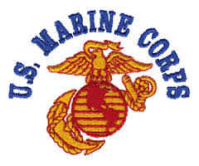 The Guest Speaker is Rich Botkin, Viet Nam Veteran and Author of “Ride the Thunder”

