Introduction
Purpose
An effective program review supports continuous quality improvement to enhance student learning outcomes and, ultimately, increase student achievement rates. Program review aims to be a sustainable process that reviews, discusses, and analyzes current practices. The purpose is to encourage program reflection, and to ensure that program planning is related to goals at the institutional and course levels.

Process
Foothill College student services programs are reviewed annually, with an in-depth review occurring on a three-year cycle. Faculty and staff in departments who contribute to these programs will participate in program review. Deans provide feedback upon completion of the template and will forward the program review on to the next stage of the process, including prioritization at the Vice Presidential level, and at OPC and PaRC.

Annual program review addresses five core areas, with a final section for administrator comments and their reflections about the next steps:
1. Data and trend analysis
2. Outcomes assessment
3. Program goals and rationale
4. Program resources and support
5. Program strengths/opportunities for improvement
6. Administrator’s comments/reflection/next steps
7. VP comments? Ask Denise

Foothill College Program Review Cycle:
2011-2012: All programs participate in an annual program review
2012-2013: 1/3 of programs participate in a comprehensive review, remaining 2/3 of programs update their annual program review

Contact: Office of Instruction and Institutional Research (650) 949-7240
Website: http://foothill.edu/staff/irs/programplans/index.php
Submission Deadline: All program review documents are due to Deans by December 14
Basic Program Information

Student Service Program Name:

Student Service Program Mission:

Please list count of faculty members (# of Fulltime and # of Part time) Ratio

Please list staff position titles

Program Review Team and Departments:
Name | Department | Position

Section 1. Data and Trend Analysis

1.1. Program/Department Data

Dimension | 2009-2010 | 2010-2011 | 2011-2012
Students Served
Full-time FTEF
Part-time FTEF
Full-time Staff
Part-time Staff

1.2 Using the data provided above, include a short narrative analysis of the following indicators. Please attach supporting studies or data to the final program review submitted to your Dean.

- Students served (How was this tracked? What is the trend?):
- Demographics analysis (Is the ethnic breakdown of students you serve proportional to the general college ethnic distribution?)
- Staffing structure (Does the staffing structure meet the program or department’s needs? If yes, please explain. If not, consider the following prompts in framing your answer.)
    - Which aspects of the work are key to the institution’s mission?
    - Has the staff increased, decreased or remained the same to meet those changes?
    - Has technology made it possible to do more work with the same staff? Or, has technology increased your workload (adding web features which need updating for example)? In what way?
    - Does the workload have significant peaks and valleys during the year? If so, describe.
    - Do you anticipate the workload will increase, decrease or remain constant in the upcoming one to three years? Is this a temporary situation?
    - If your workload is increasing and resources will not allow for increased staffing, how do you anticipate being able to ameliorate the negative consequences of too much work and maintain a positive atmosphere?
    - What steps can be taken to improve your program or department’s organizational efficiency within its current budget?
    - What strategies have been used to improve the delivery of support services within the program or department?
- Workload measures (includes budget details). Describe the program’s workload measures as developed within the Student Services process. Ask Denise
- Budget analysis categories of expenditures (A Budget, Equipment, Supplies) Ask Denise
- Basic Skills Programs (if applicable). For more information about the Core Mission of Basic Skills, see the Basic Skills Workgroup website: http://foothill.edu/president/basicskills.php
  - Please discuss current outcomes or initiatives related to this core mission.
- Transfer Programs (if applicable). For more information about the Core Mission of Transfer, see the Transfer Workgroup website: http://foothill.edu/president/transfer.php
  - Please discuss current outcomes or initiatives related to this core mission.
- Workforce/Career Technical Education Programs (if applicable). For more information about the Core Mission of Workforce, see the Workforce Workgroup website: http://foothill.edu/president/workforce.php
  - Please discuss current outcomes or initiatives related to this core mission.
- Student Equity: Foothill-De Anza Community College District Board policy and California state guidelines require that each California community college submit a report on the college’s progress in achieving equity in five specific areas: access, course completion, ESLL and basic skills completion, degree and certificate completion, and transfer. For the latest draft of the Student Equity Report, please see the ESMP website: http://foothill.edu/staff/irs/ESMP/index.php
  - To better inform the Student Equity efforts at Foothill College, please comment on any current outcomes or initiatives related to increasing outreach, retention and student success of underrepresented students in your program.

Section 2. Learning Outcomes Assessment Summary

2.1. Insert – 2011-2012 Four Column Report for SA-SLO Assessment from TracDat, please contact the Office of Instruction to assist you with this step if needed.

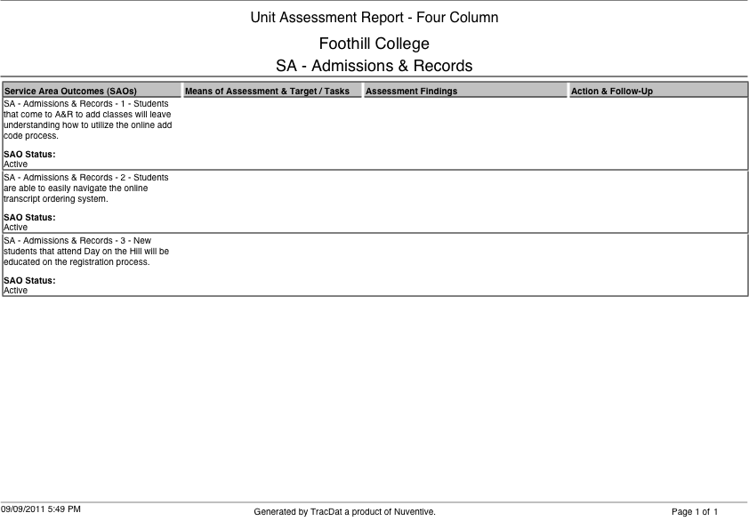

2.3 Service Area Student Learning Outcomes: Please provide observations and reflections below.

2.3.a What findings can be gathered from the SA-SLOs assessments?

2.3.b Does any of the data suggest that revisions might be necessary in order for students to successfully achieve the SA-SLOs?

2.3.c Do the SA-SLOs reflect the knowledge, skills and abilities students need from those services in order to succeed?

2.3.d How has assessment of SA-SLOs led to improvement in student success at the institution?

Section 3: Program Goals and Rationale

Program goals should be broad and incorporate some sort of measurable action that connects to Foothill’s core missions, Educational & Strategic Master Plan (ESMP), the division plan, and SLOs.

3.1 Previous program goals from last academic year
Goal | Original Timeline | Actions Taken | Status/Modifications

3.2 New Goals: Goals can be multi-year
Goal | Timeline (long/short-term) | How will this goal improve student success or respond to other key college initiatives | Action Steps

Section 4: Program Resources and Support

4.1 Using the tables below, summarize your program’s new, unfunded resource requests. Refer to the Operations Planning Committee website: http://foothill.edu/president/operations.php for current guiding principles, rubrics and resource allocation information.
Shirley-Cheat sheet for how to price reassign time, etc.

Full Time Faculty and/or Staff Positions
Position | $ Amount | Related Goal from Table in section 3.2

Unbudgeted Reassigned Time (calculate by % reassign time x salary/benefits of FT)
Position | $ Amount | Related Goal from Table in section 3.2

One-time B Budget Augmentation
Description | $ Amount | Related Goal from Table in section 3.2

Ongoing B Budget Augmentation
B Budget FOAP | $ Amount | Related Goal from Table in section 3.2

Facilities and Equipment
Facilities/Equipment Description | $ Amount | Related Goal from Table in section 3.2

Section 5: Program Strengths/Opportunities for Improvement

5.1 Address the concerns or recommendations that were made in prior program review cycles.

5.2 What statements of concern have been raised in the course of conducting the program review by faculty, administrators, students, or by any member of the program review team regarding overall program viability?

5.3 After reviewing the data, what strengths or positive trends would you like to highlight about your program?

Section 6: Feedback and Follow Up

This section is for the Dean to provide feedback.

6.1 Strengths and successes of the program as evidenced by the data and analysis:

6.2 Areas of concern, if any:

6.3 Recommendations for improvement:

6.4 Recommended next steps:
___ Proceed as planned on program review schedule
___ Further review/Out of cycle in-depth review

