2020 RESPIRATORY THERAPY PROGRAM APPLICATION INSTRUCTIONS

Application Deadline: April 30, 2020 at 11:59pm PDT

Our Respiratory Therapy Application is now ONLY available online. Please make sure that you give yourself enough time to read through the instructions so that you can submit a complete application, by the deadline.

Please follow the instructions below to submit your 2020 Respiratory Therapy Application

Before you apply

- Please visit the Respiratory Therapy website and read the available information. Respiratory Therapy Program Website <-- click here

- In order to apply to the Respiratory Therapy Program, you must obtain a campus wide identification number or CWID. If you don't have a CWID, you may obtain one by submitting an application to Foothill College, at no cost to you. For more information on how to do this, please visit Foothill College’s Registration Website:
Foot hill Col leg e’s Reg ist ration Website <-- click here

Application Requirements

- Make sure you're ready and eligible to apply, by reviewing the program prerequisites, requirements to apply and the application worksheet.
Program Prerequisites <-- click here
For help calculating your cumulative college GPA, visit: https://foothill.edu/counseling/gpacalc.html

Required Documents: Please obtain copies of the following documents, and be prepared to upload them and attach them to your application.
Official Electronic Transcripts (e-transcripts) from ALL colleges attended. If you have prerequisite coursework completed from Foothill College or De Anza College you must enter the coursework where appropriate on application. We can verify your successful completion of that coursework internally. Official Foothill College and/or De Anza College transcripts are not required.

Additional Documents: You are welcome to include the following documents, if they apply to you, or you would like to include them with your application.
- Approved petitions (required if applicable)
- Math Placement results
- Documentation of completion of CSU or IGETC General education
Transcripts
Due to the transition of our application system, if you are a previous applicant you must submit all new official electronic transcripts to Foothill College Admissions and Records.
Official Foothill College and/or De Anza College transcripts are not required. If you have prerequisite coursework completed from Foothill College or De Anza College you must enter the coursework where appropriate on the application. We can verify your successful completion of that coursework internally.
You should obtain your College Transcripts by requesting a copy from all the Colleges you've attended. Typically, registrar offices or registration departments at the corresponding college will assist you with this. Please note that unofficial copies will not be accepted and may automatically disqualify you. For the 2020 application, you must request that electronic transcripts or e-transcripts be sent to Foothill College Admissions and Records at: fhtranscripts@fhda.edu. If your school doesn't offer this option, please send hard copies to:
Admissions and Records
RSPT 2020
Foothill College 12345 El Monte Road,
Los Altos Hills, CA 94022

Remember that if you received an Associate's Degree from a California Community College and/or Bachelor's degree from a UC or CSU, completion of your General Education requirements will be waived.
You will have to submit an Equivalency Petition Form through our counseling department, if you have completed prerequisite coursework outside of Foothill College, and the course/s you have completed is/are not included in the Respiratory Therapy Equivalency Form. If this is the case, please download the form, fill it out, include documentation supporting your petition, and make an appointment with a Foothill counselor.
Respiratory Therapy Equivalency Chart <-- click here

Petition Form <-- click here

Foothill College Counseling <-- click here

If you cannot obtain any of the required documents, please be prepared to provide a letter of explanation, which will be attached to your application.
Please see our Sample Respiratory Therapy Application. This sample looks very similar to the actual application. As a result, you may use it as an example of the information you will be submitting when you apply. Feel free to fill it out!
Respiratory Therapy Program Website <-- click here

Scanning and Saving Required and Optional Documents

- Please save the required documents (listed above) to the computer you intend to use, when applying. We recommend that you put together a file with all of these documents, so that they can be easily accessed while you're completing your application. Please note that you will only be allowed one file attachment for each required section. As a result, your college transcripts, for example, must all be uploaded as one file. For assistance on how to scan documents into one file, combine multiple files into one file, save files into one folder, or other alternative options, please visit the Foothill College's ASFC Smart Shop:
ASFC Smart Shop <-- click here

Begin your application

- When you are ready, begin your 2020 Respiratory Therapy program application here: My Portal <-- click here

- Log into My Portal.

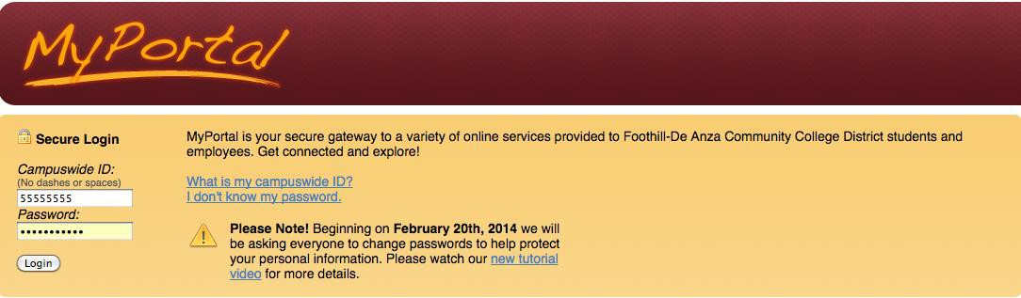

- Click on the Students tab.

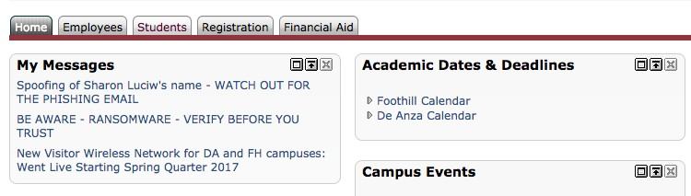

- Find the Apply to Allied Health Programs Channel.

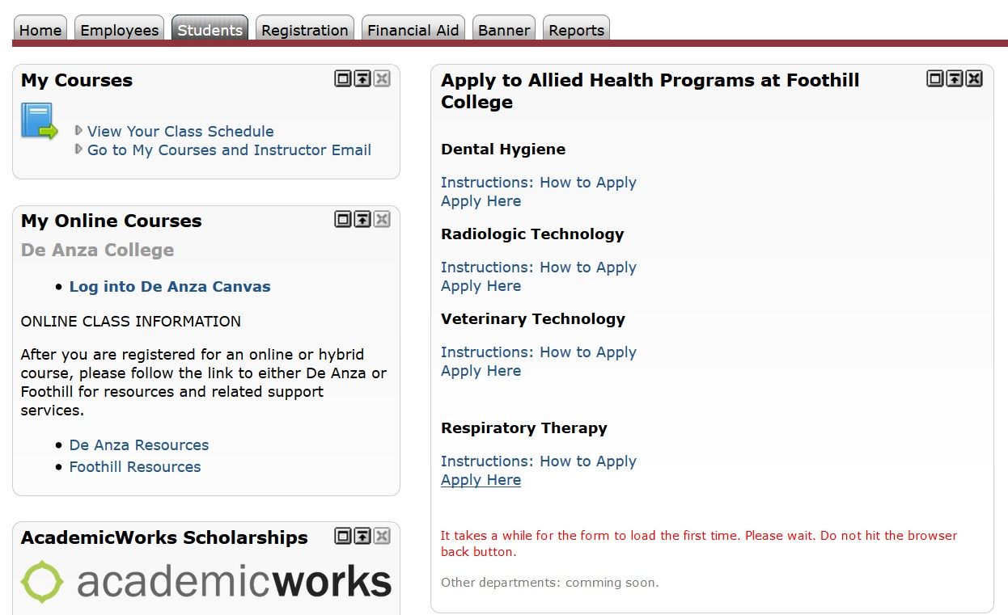

- Find the Apply Here link.

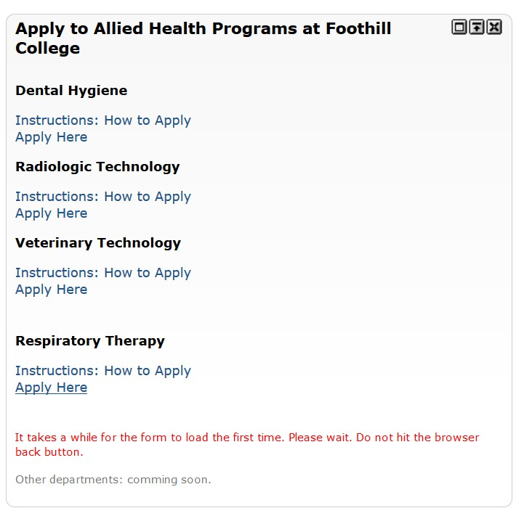

- Fill out and complete your 2020 Respiratory Therapy Application. Your application progress will be saved until the deadline. You will receive an email after you've begun your application, to the email displayed on your application.

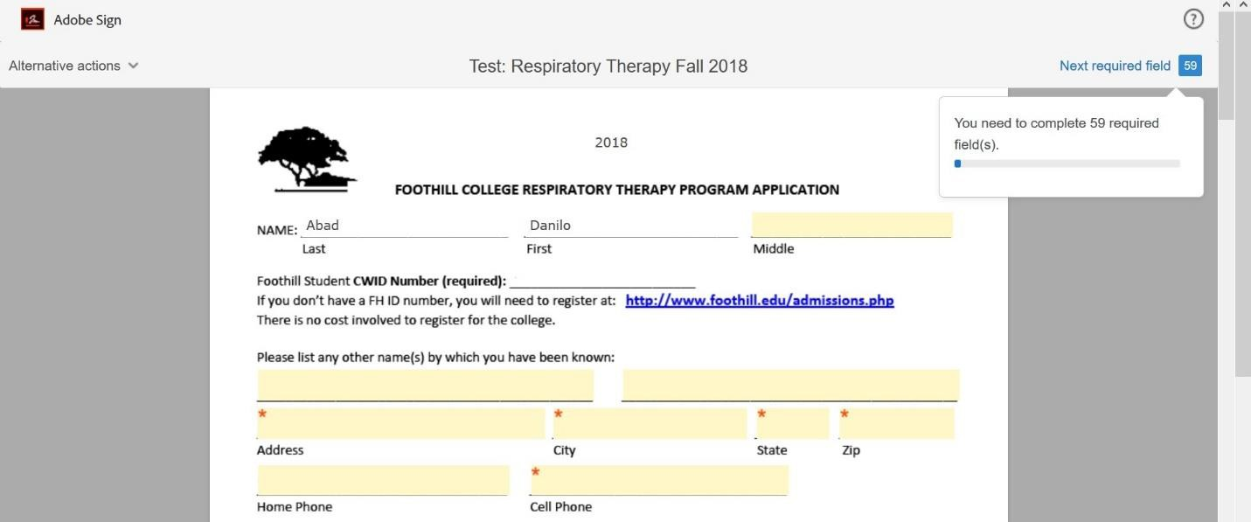

- Attach all required/optional documents by clicking on the designated boxes. After you click, you will be asked to choose from your saved files to upload.

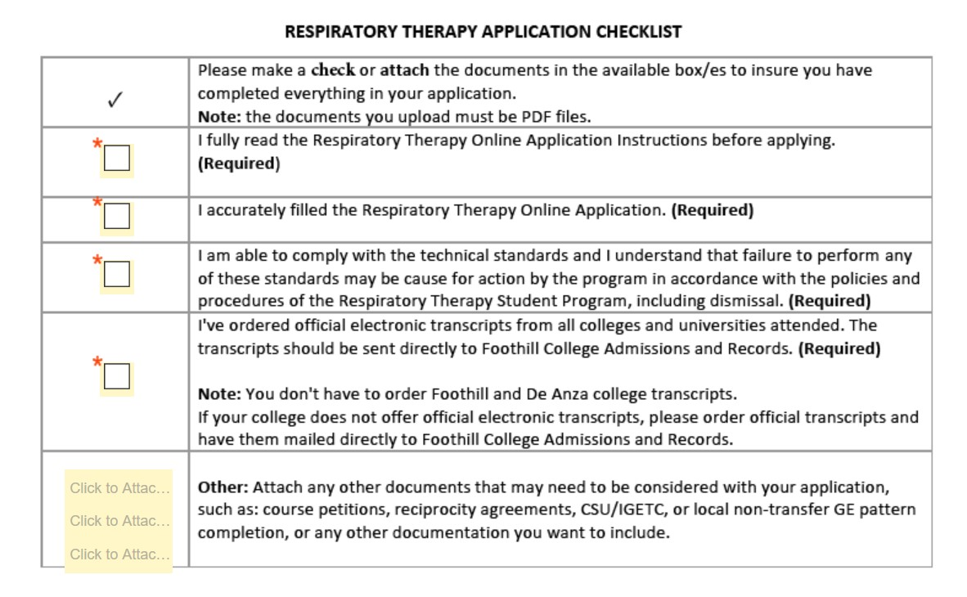

Submit your application

- When you are ready, submit your program application by signing it electronically. You will not be able to do this, until you have filled all of the required sections. No changes will be allowed after you've signed the application. Applicants may submit one Respiratory Therapy application per year. Please make sure to review your application thoroughly, for accuracy. This is very important.

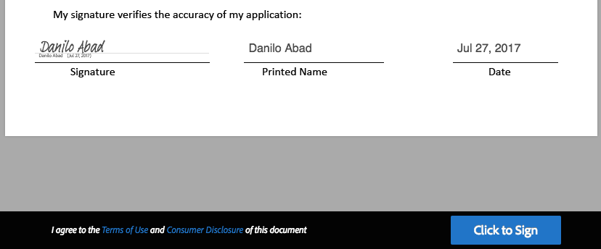

- You will be receiving an email confirming that you've successfully submitted your application, along with a copy of it, for your records. The email will be sent to the email address linked to your MyPortal account, and displayed on the first page of the application.

Program application deadline: April 30, 2020 at 11:59pm PDT

If you have questions, please contact: FH Health Career Programs
HealthCareerPrograms@fhda.edu

