Quick Guide to MyPortal Registration – Updated 5/23/2025

Access Student Registration Tools in MyPortal
- Log into MyPortal at myportal.fhda.edu with an approved Web browser. 
- SELECT Student Registration Card.
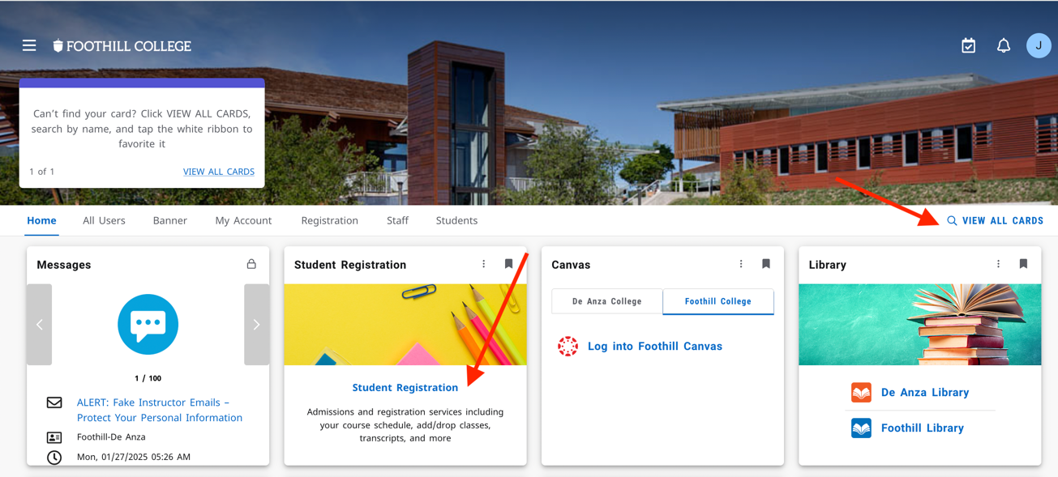
Tip: Can't find the Student Registration Card? Follow the prompt on the top left announcement to VIEW ALL CARDS.
- Under Student Registration, SELECT Registration Dashboard.
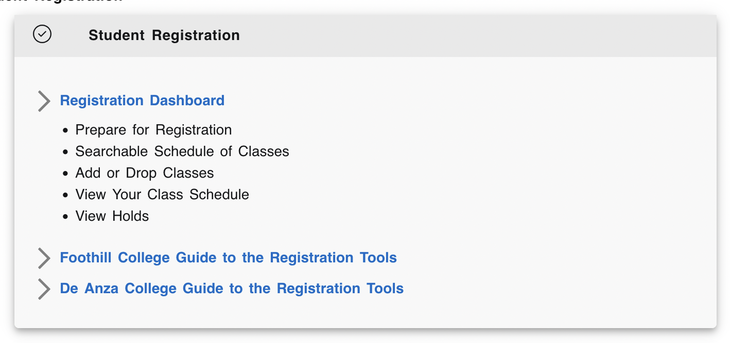

From the Registration Dashboard, Choose What You Would Like to Do
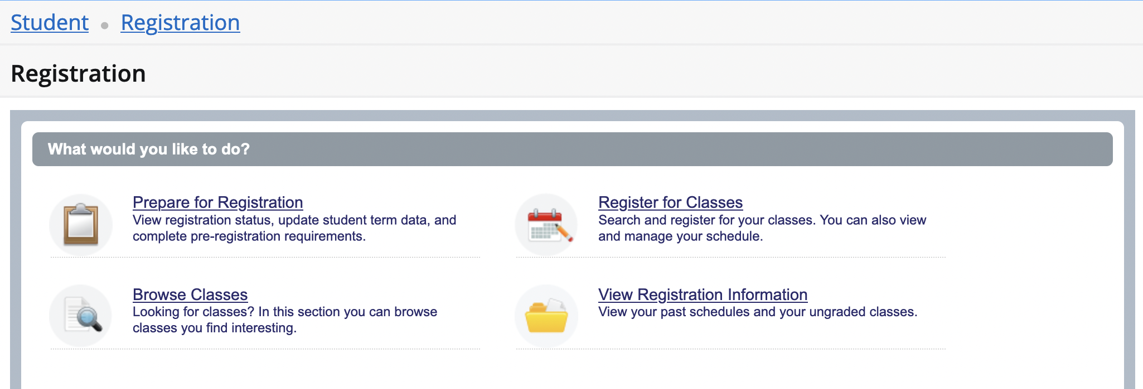

- Select one of four links, depending on what you want to do.
  - Prepare for Registration – View registration status, holds, and your date and time ticket to register for a selected term.
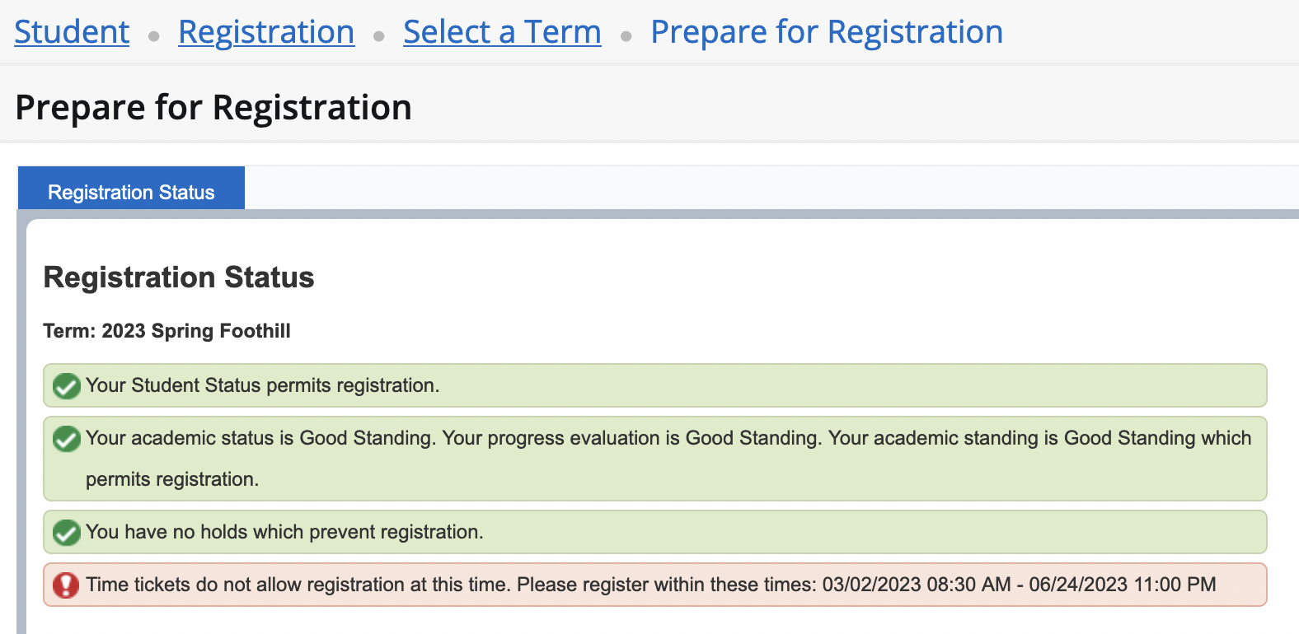

  - Browse Classes – Search for classes to plan your class schedule before you register. Follow steps below and note the CRN (Course Registration Number) for the classes you want to take. You’ll use them during registration.

    - SELECT a term and campus (Foothill) > CLICK Continue
    - TYPE and/or SELECT Subjects or Key Words > CLICK Search
    - For more information about each search result, CLICK a Course Title to display a pop up with more information. Also HOVER your cursor to the right of a title over the CRN or Meeting Times. NOTE: CLICK Instructor name for instructor’s email. You can also change the width of columns for improved viewing.
    - TIP: You may also browse the Foothill searchable schedule at foothill.edu/schedule or search for classes to add during the registration process.

  - Register for Classes – Here you’ll add, waitlist or drop a class. When registering, you can Find Classes to add, OR most easily Enter CRNs (Course Registration Number) to register. Also manage your schedule, including requesting grade of pass/no pass. View the STEPS TO REGISTER FOR CLASSES section below for complete details.
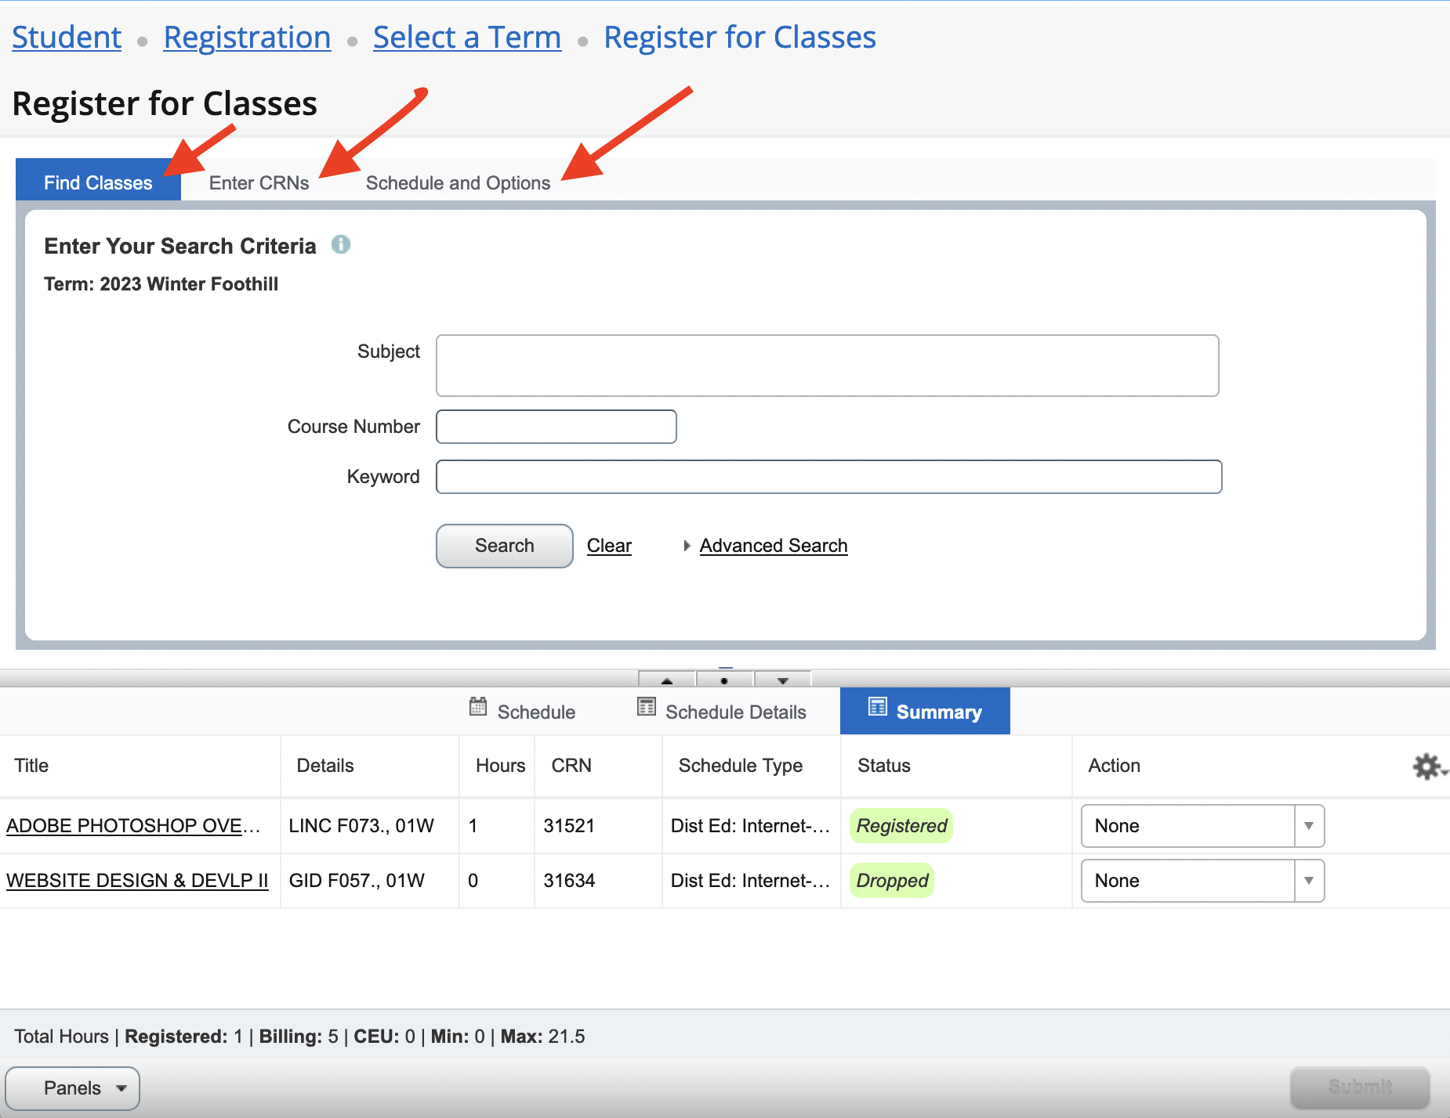
  - View Registration Information – View your past schedules and ungraded classes by term, and active registrations for current term.
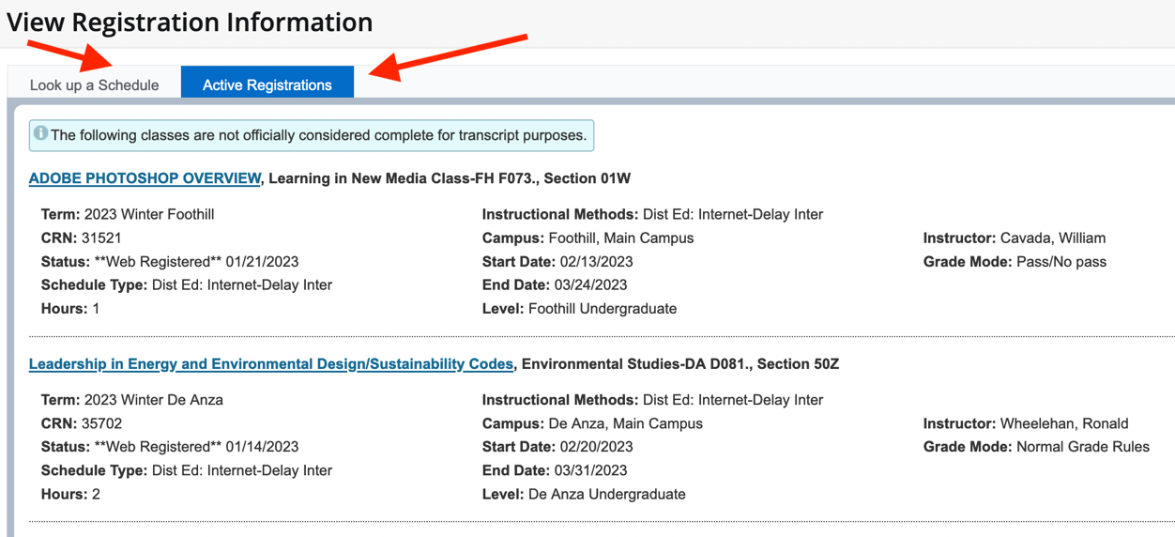

Steps to Register for Classes in MyPortal

- From Registration Dashboard, CLICK Register for Classes.
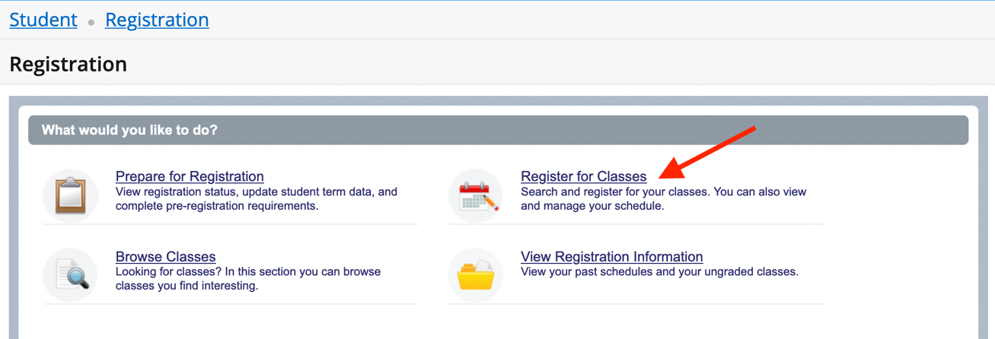

- SELECT a Term and College (Foothill)

Note: If you select a future term even if eligible to register with a date and time, you cannot access the Register for Classes section until your specified date and time, and will see a message to that effect.
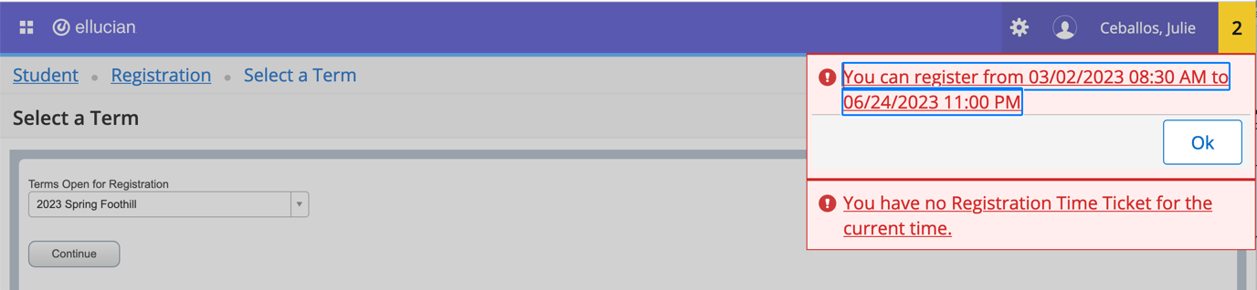

If you are an enrolled student, you can access the current term Register for Classes page.

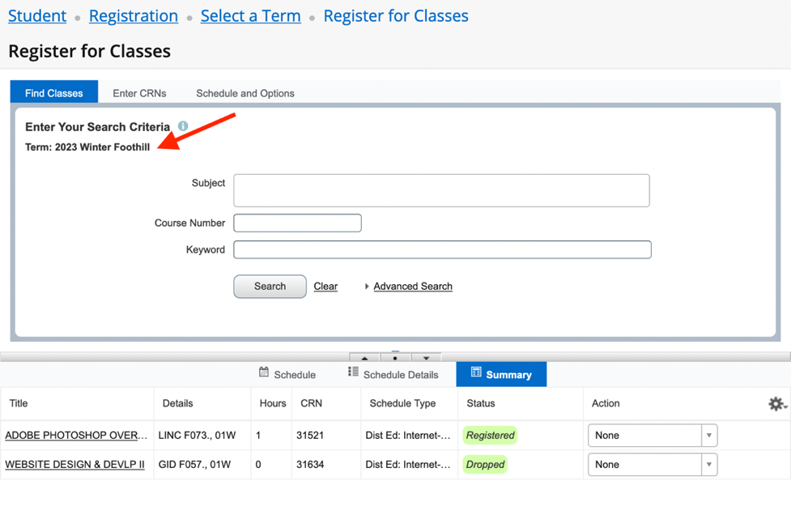
- FIND CLASSES or ENTER CRNs
To add a class, SELECT either the Find Classes or Enter CRNs tab.
  - Find (Search) Classes > TYPE in Subjects > CLICK Search
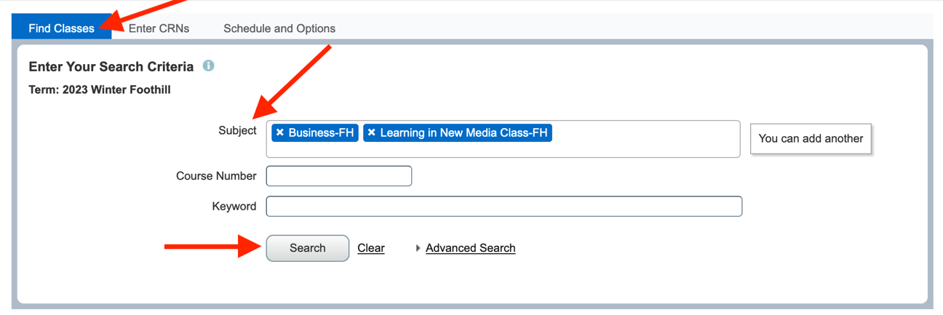

> VIEW Results > CLICK Course Title for more info > CLICK Add or Search Again
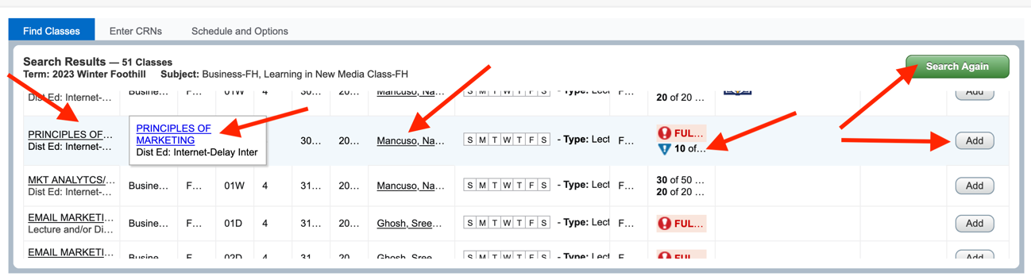

  - Enter CRNs > Type in CRNs > CLICK Add to Summary
To most quickly add classes, enter the CRNs (Course Registration Number) of the course sections you noted while planning your schedule.
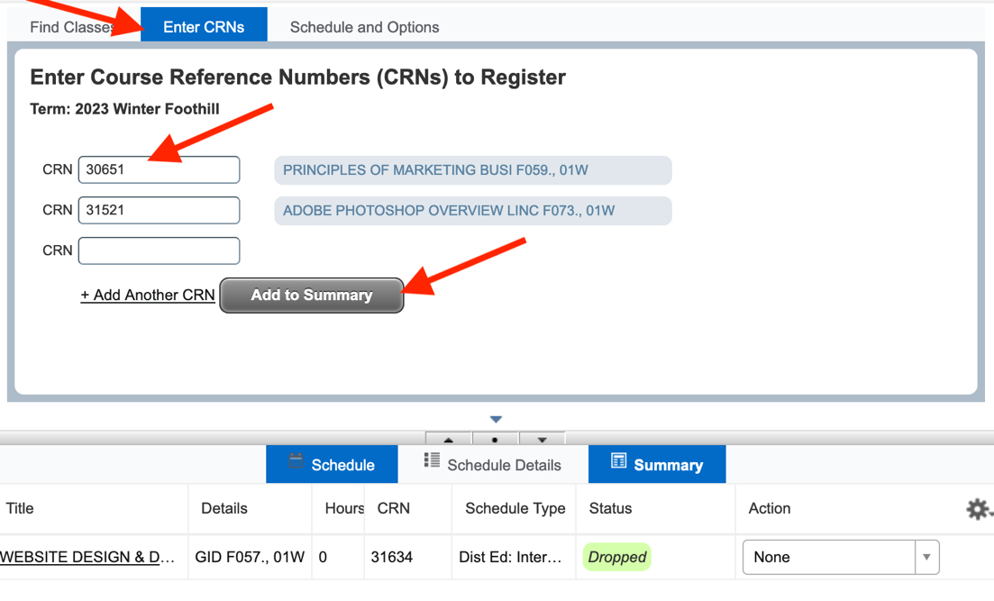
- COMPLETE Add Registration

  - After you add a course(s) to your Summary, you must confirm you want to add the class to your schedule. Under Action, see the Action to be confirmed, and CLICK Submit.
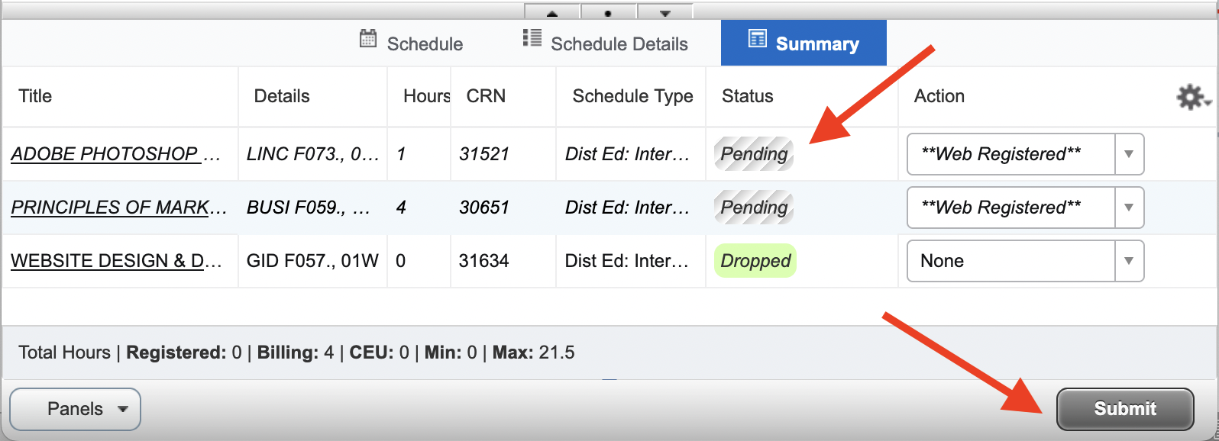
- ADD Your Name to a Waitlist
  - If a course is closed with a Waitlist, follow the same steps to add the class to your Summary, then SELECT Waitlist from the dropdown menu > CLICK Submit.
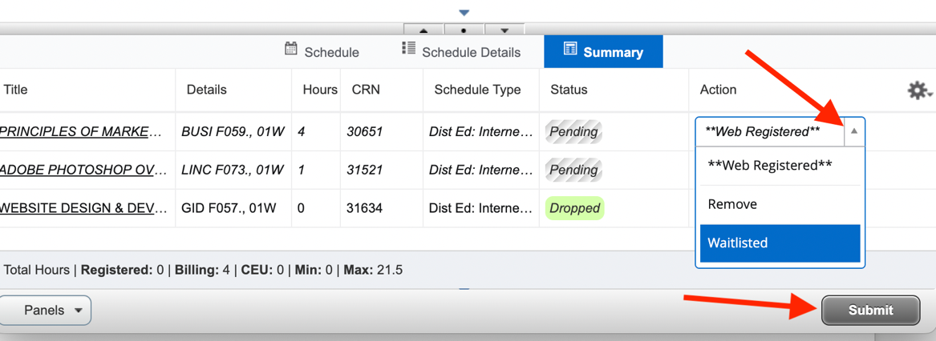
  - To find your place on the Waitlist, SELECT Schedule Details tab. See c. instruction details below to view your waitlist placement.
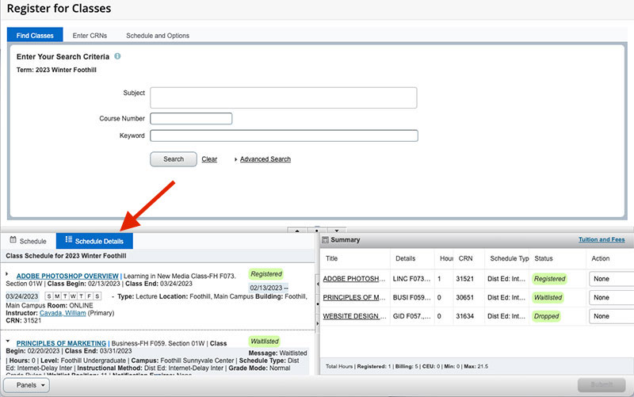
  - CLICK the pointer next to class title to see more information. It will point down to show Waitlist Position #.
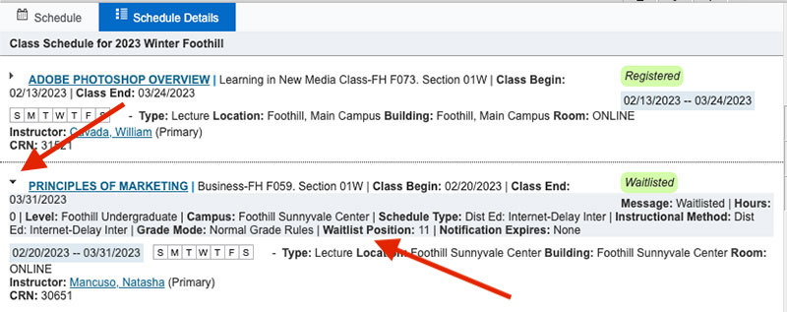
- ADD with an Add Authorization Code (see 6. c. if you are on a waitlist)
  - When given an ADD CODE, to register, SELECT the Enter CRN tab > Type the 5-digit CRN for the class > CLICK Add to Summary (see 3. b. above) > A screen to enter the add code will pop up. > ENTER the Add Authorization Code provided (copy/paste from instructor’s email when possible) > CLICK Confirm
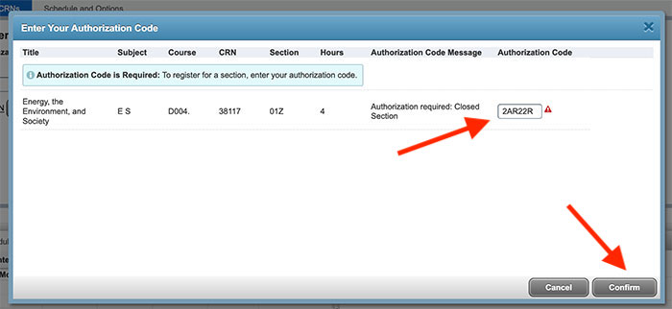
  - On your Summary, if there are no registration errors, you will see a Pending Status with **Web Registered ** > CLICK Submit > Status will change to Registered
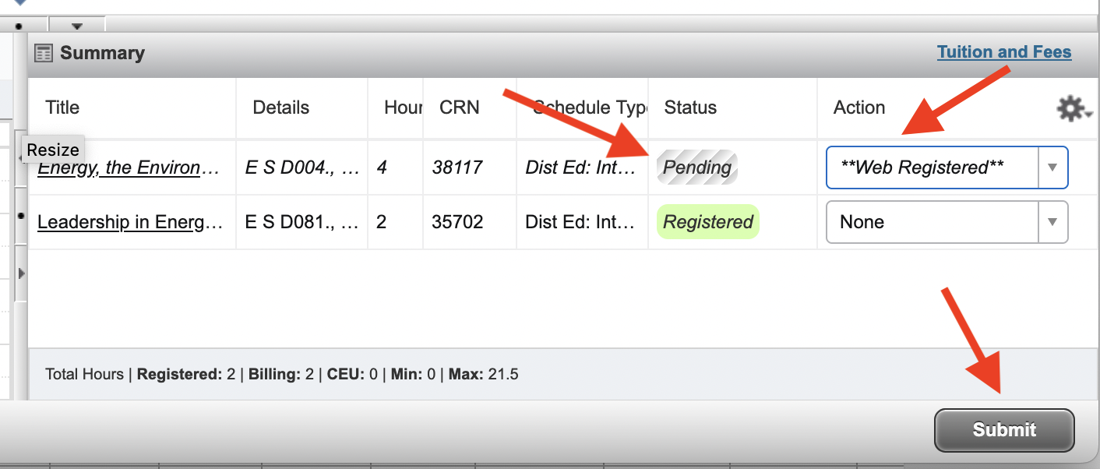
  - Waitlisted Add Codes:
    - An instructor may not issue Add Codes to all students on the waitlist once the quarter begins. It is best to email the instructor to see if it is possible to be added, noting that you are on the waitlist.
    - NOTE: If you are provided an ADD CODE for a class in which you are on the waitlist, you will need to first DROP the class from your summary (See 7. a. below).
    - Then follow steps above to ADD with an Add Authorization Code.
- DROP/WITHDRAW from a Class

  - VIEW your Summary Registered or Waitlisted classes > SELECT **Web Dropped** from the Action menu > CLICK Submit
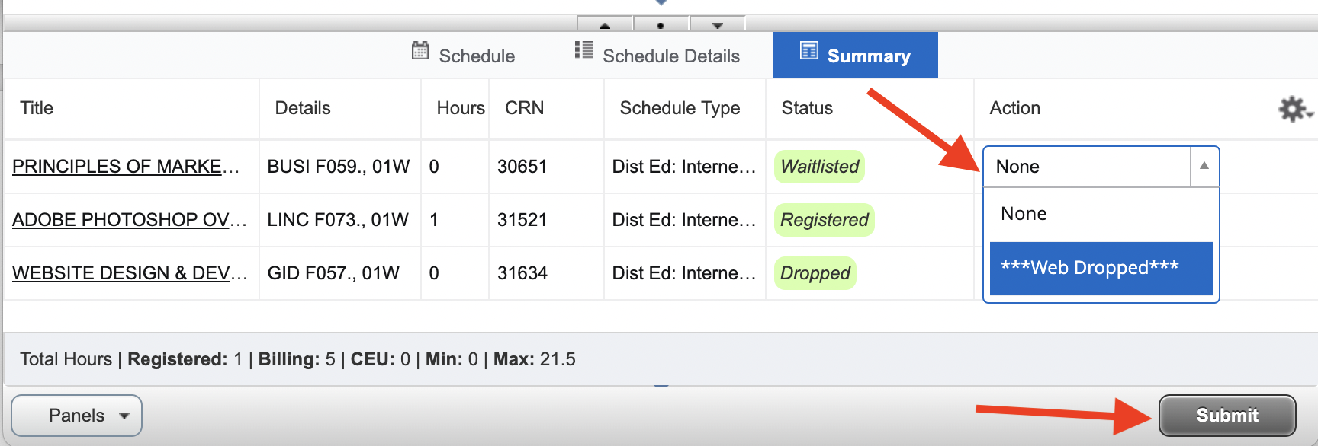
- REQUEST PASS/NO PASS
  - Before choosing the option, please review our Pass/No Pass Guidelines.
  - For courses that offer this option, you can choose Pass/No Pass > SELECT Schedule and Options > Under Grade Mode, SELECT from the dropdown menu > SELECT Pass/No Pass if available > You will be prompted to Save
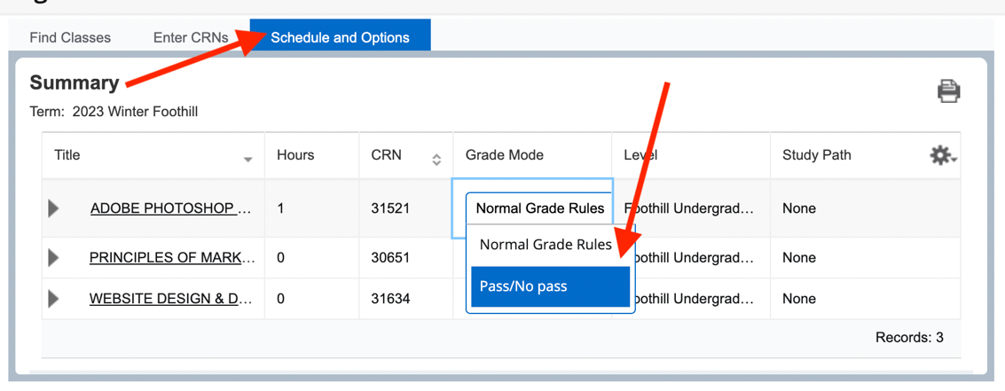
- PAY YOUR FEES
  - CLICK on the Tuition and Fees link in your Summary Box
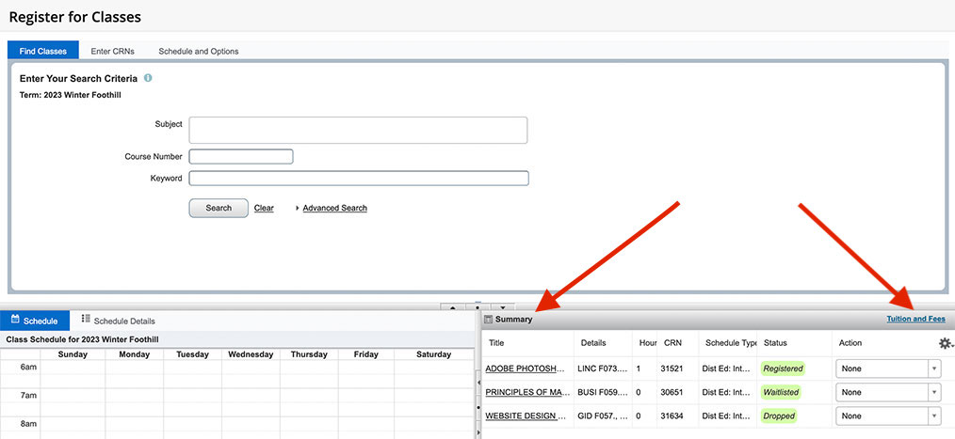
  - VIEW your account details
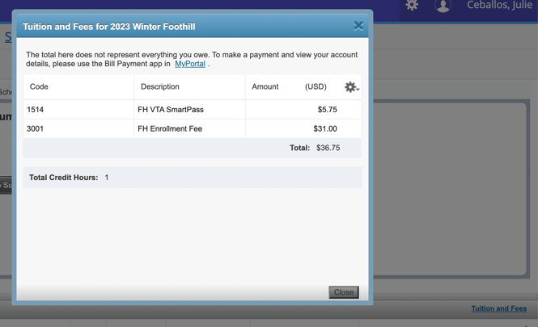
  - To pay your fees, use the Bill Payment under MyPortal Student Registration.
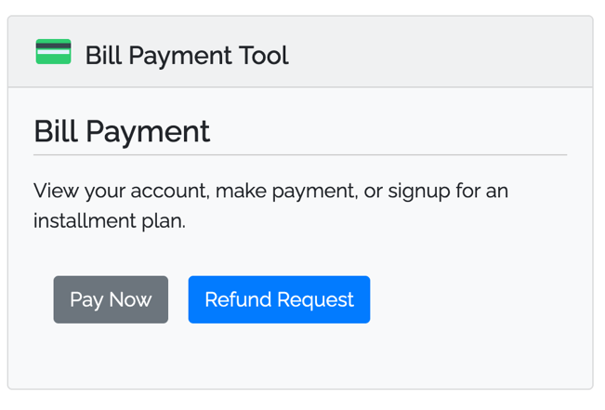
NEED HELP PAYING YOUR FEES?
Learn about payment policies, including drop for nonpayment and methods of payment on the Cashier's Office website and visit the Financial Aid Office for ways we can help.

