2020 RADIOLOGIC TECHNOLOGY PROGRAM APPLICATION INSTRUCTIONS

Application Deadline: March 1st by 11:59pm PST

Our Radiologic Technology Application is now available online. Please make sure to give
yourself enough time to read through the instructions so that you are able to
submit a complete application by the deadline.

Please follow the instructions below to ensure completion of your
Radiologic Technology Application

Before you apply

- Please visit the Radiologic Technology website and read the available information.
Radiologic Technology Program Website <-- click here

- In order to apply to the Radiologic Technology Program, you must obtain a campus wide identification number (CWID). If you don't have a CWID, you may obtain one by submitting an application to Foothill College, at no cost to you. For more information on how to do this, please visit Foothill College Registration Website:
Foothill College’s Registration Website <-- click here

Application Requirements

- Make sure you're ready and eligible to apply by reviewing all of the program prerequisites and requirements. Be sure to review the sample application to get a thorough understanding of what to expect once you open up your official application.
Program Prerequisites <-- click here

Required Documents: Please obtain the following documents

Official Electronic Transcripts (e-transcripts) from ALL colleges attended. If you have prerequisite coursework completed from Foothill College or De Anza College you must enter the coursework where appropriate on application. We can verify your successful completion of that coursework internally. Official Foothill College and/or De Anza College transcripts are not required.

Additional Documents: Please include the following required documents, if applicable:
  - RT200L Approved petition
  - Documentation of completion of CSU or IGETC General education
  - Math Placement Test result
Transcripts

Due to the transition of our application system, if you are a previous applicant who applied
before 2018, you must submit all new official electronic transcripts to Foothill College Admissions
and Records. Transcripts from Foothill College and DeAnza College are not required. You should obtain your College Transcripts by requesting a copy from all the Colleges you've attended. Typically, registrar offices or registration departments at the corresponding college will assist you with this. Please note that unofficial copies will not be accepted and may automatically disqualify you. For the 2020 application, you must request that electronic transcripts or e-transcripts be sent to Foothill College Admissions and Records at: fhtranscripts@fhda.edu. If your school doesn't offer this option, please send hard copies to:

Admissions and Records
RT2020
Foothill College
12345 El Monte Road
Los Altos Hills, CA 94022

Please note that if you received an Associate's Degree from a California Community College and/or Bachelor's degree from a UC or CSU, completion of your General Education requirements will be waived.

You will need to submit an Equivalency Petition Form through our counseling division if you have completed prerequisite coursework outside of Foothill College, and the coursework you have completed is not included in the RT Equivalency or FH Transfer Equivalency guides. If this is the case; please download the form, fill it out, include documentation supporting your petition, and make an appointment with a Foothill College counselor. The counselor will determine whether or not you will need to submit a petition. Please note: the deadline to petition for RT200L is Dec. 1st by noon. No petitions will be considered for RT200L after Dec. 1st, noon. Please contact Rachelle Campbell at campbellrachelle@fhda.edu regarding RT200L and to request the RT 200L Petition Form.

Radiologic Technology Equivalency Chart <-- click here
FH College Transfer Equivalency Guide <-- click here
General Petition Form <-- click here
Foothill College Counseling <-- click here

If you cannot obtain any of the required documents, please be prepared to provide a letter of explanation, which will be attached to your application.
Please see our Sample Radiologic Technology Program Application. This sample application is similar to the official application. As a result, you may use it as a tool to help you successfully complete application information you will be submitting when you apply. Please click #3 at the link below:

Radiologic Technology Application Process <-- click here

Scanning and Saving Required Documents

- Please save the required documents (listed above) to the computer you intend to use, when
applying. We recommend that you put together a file with all of these documents, so that they can be easily accessed while you're completing your application. Please note that you will only be allowed three attachments. As a result, all documents must be uploaded as a maximum of three files. For assistance on how to scan documents into one file, combine multiple files into one file and save files into one folder or other alternative options, please visit the Foothill College's ASFC Smart Shop:

ASFC Smart Shop<-- click here

Begin your application

- When you are ready to enter your information to the 2020 Radiologic Technology program application, this is where you will locate it:
My Portal <-- click here

- Log into My Portal.

- Click on the Students tab.

- Find the Allied Health App.

- Click the Apply link.

- Fill out and complete your 2020 Radiologic Technology Application. Your application progress
will be saved until the deadline. You will receive an email after you've begun your application,
that will be sent to the email displayed on your application.

- Attach all required documents by clicking on the designated boxes with a red asterisk *. After you click, you will be asked to choose from your saved files to upload.
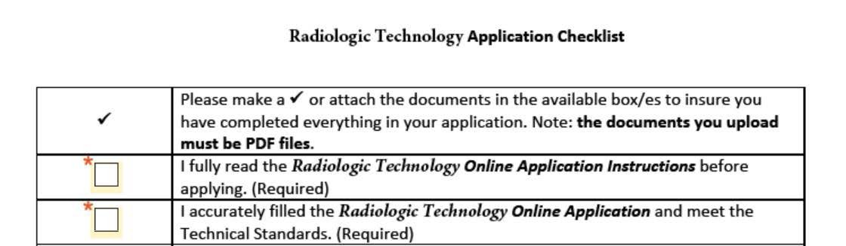

Submitting your application

- When you are ready, submit your program application by signing it electronically.
You will not be able to complete this, until you have filled all of the required sections.
No changes will be permitted after you've signed the application.

Applicants may submit one Radiologic Technology application per year.

Please make sure to review your application thoroughly. Accuracy is vital.



- You will be receiving an email with a copy of your completed application attached, confirming that you've successfully submitted your application. The email will be sent to the email linked to your MyPortal account. If you do not receive an e-mail confirmation of you successful application submission, please log back into My Portal to review and resubmit your application.

Program Application deadline: March 1st, by 11:59pm PST

