PHARMACY TECHNICIAN PROGRAM APPLICATION INSTRUCTIONS

Application Deadline: June 1 at 11:59pm PDT or until the program is filled

Our Pharmacy Technician Application is now available online. Please make sure that you give yourself enough time to read through the instructions so that you can submit a complete application, by the deadline.

Please follow the instructions below to submit your Pharmacy Technician Application:

Before you apply:

- Please visit the Pharmacy Technician website and read the available information. Pharmacy Technician Program Website <-- click here

- In order to apply to the Pharmacy Technician Program, you must obtain a campus wide identification number or CWID. If you don't have a CWID, you may obtain one by submitting an application to Foothill College, at no cost to you. For more information on how to do this, please visit Foothill College’s Registration Website:
Foot hill Col leg e’s Reg ist ration Website <-- click here

Application Requirements

- Make sure you're ready and eligible to apply, by reviewing the program prerequisites, requirements to apply and the application worksheet.
Program Prerequisites <-- click here
For help calculating your cumulative college GPA, visit: https://foothill.edu/counseling/gpacalc.html

Required Documents: Please obtain copies of the following documents, and be prepared to upload them and attach them to your application.
  - Official Electronic Transcripts (e-transcripts) from ALL colleges attended, except for Foothill and De Anza Colleges.

Additional Documents: You are welcome to include the following documents, if they apply to you, or you would like to include them with your application.
- Approved petitions (required if applicable)
- Math Placement results
- Documentation of completion of CSU or IGETC General education
- BLS Card copy

Transcripts

Due to the transition of our application system, if you are a previous applicant you must submit all new official electronic transcripts to Foothill College Admissions and Records.
Official Foothill College and/or De Anza College transcripts are not required. If you have prerequisite coursework completed from Foothill College or De Anza College you must enter the coursework where appropriate on the application. We can verify your successful completion of that coursework internally.
You should obtain your College Transcripts by requesting a copy from all the Colleges you've attended. Typically, registrar offices or registration departments at the corresponding college will assist you with this. Please note that unofficial copies will not be accepted and may automatically disqualify you. You must request that electronic transcripts or e-transcripts be sent to Foothill College Admissions and Records: fhtranscripts@fhda.edu. If your school doesn't offer this option, please mail them to:

Admissions and Records PHT 2020
Foothill College
12345 El Monte Road
Los Altos Hills, CA 94022

Remember that if you received an Associate's Degree from a California Community College and/or Bachelor's degree from a UC or CSU, completion of your General Education requirements will be waived.
If you cannot obtain any of the required documents, please be prepared to provide a letter of explanation, which will be attached to your application.

Please see our Sample Pharmacy Technician Program Application. This sample looks very similar to the actual application. As a result, you may use it as an example of the information you will be submitting when you apply. Feel free to fill it out!

Pharmacy Technician Program Sample Application<-- click here

Scanning and Saving Required and Optional Documents

- Please save the required documents (listed above) to the computer you intend to use, when applying. We recommend that you put together a file with all of these documents, so that they can be easily accessed while you're completing your application. Please note that you will only be allowed one file attachment for each required section. As a result, your college transcripts, for example, must all be uploaded as one file. For assistance on how to scan documents into one file, combine multiple files into one file, save files into one folder, or other alternative options, please visit the Foothill College's ASFC Smart Shop:
ASFC Smart Shop <-- click here

Begin your application

- When you are ready, begin your Pharmacy Technician program application here: My Portal <-- click here

- Log into My Portal.

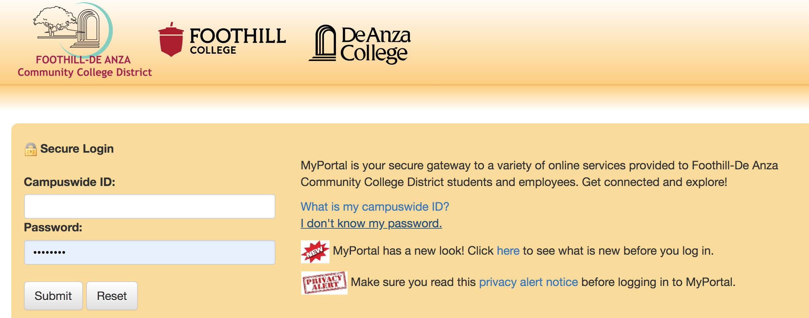

Click on the Apps tab.

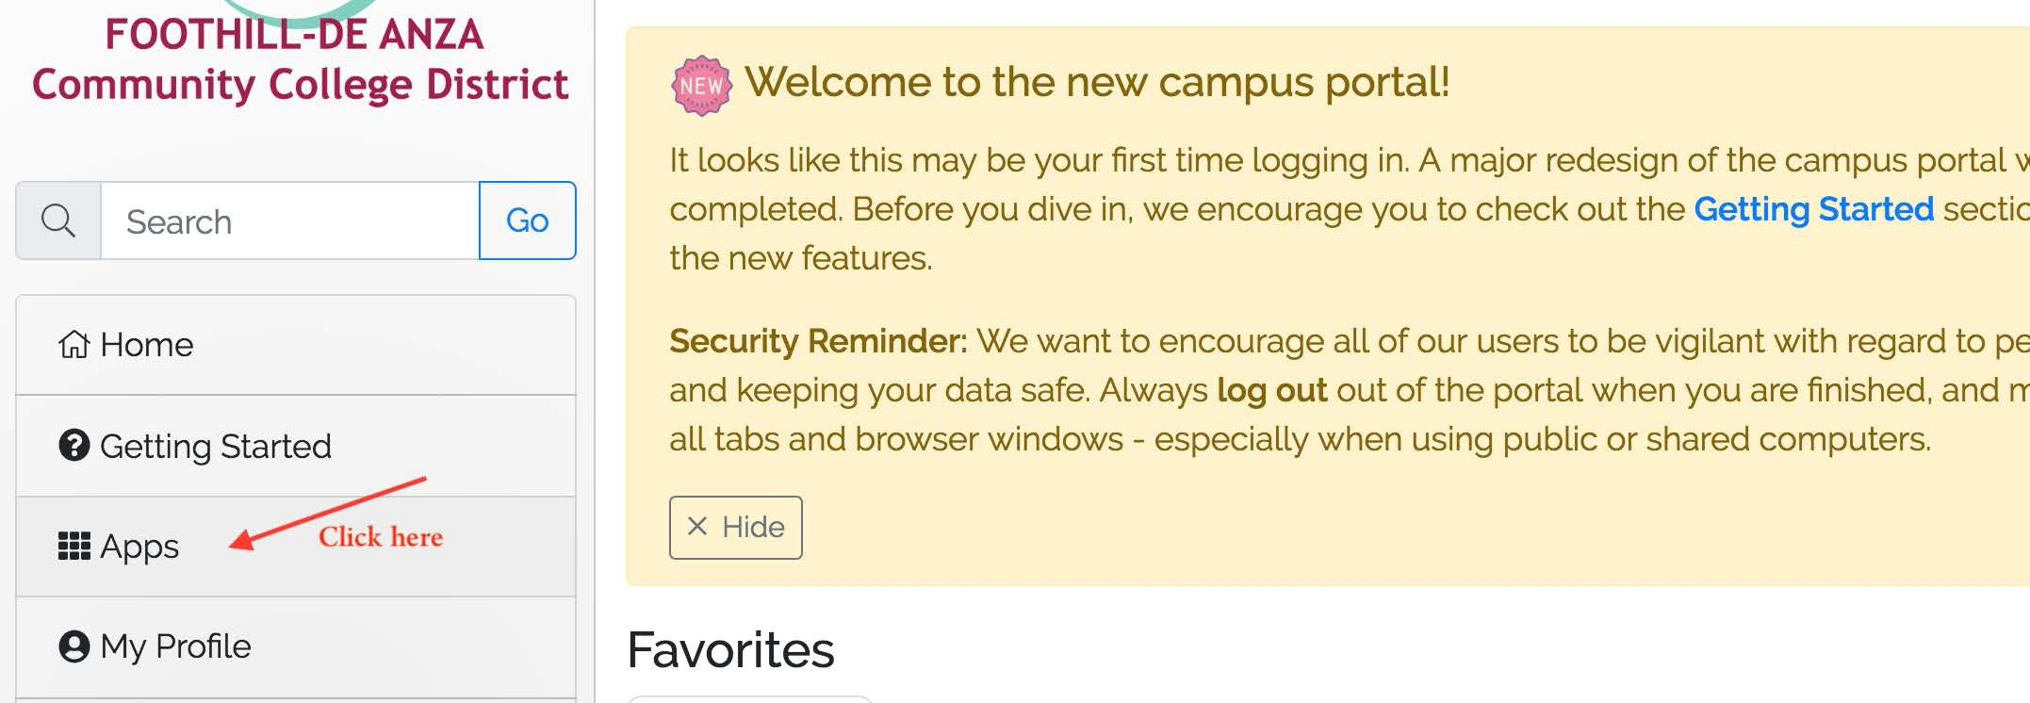

- Find the Allied Health icon and click on it

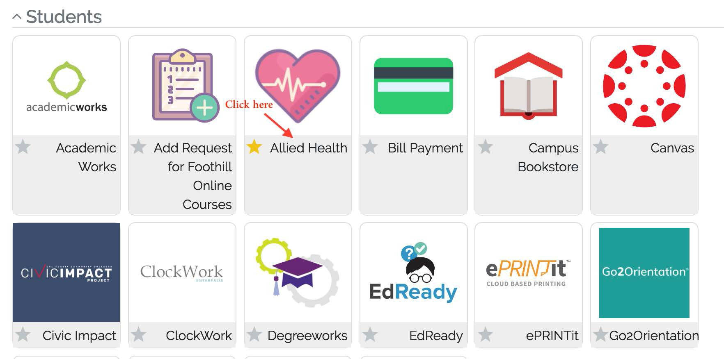
- Find the Apply Here link.

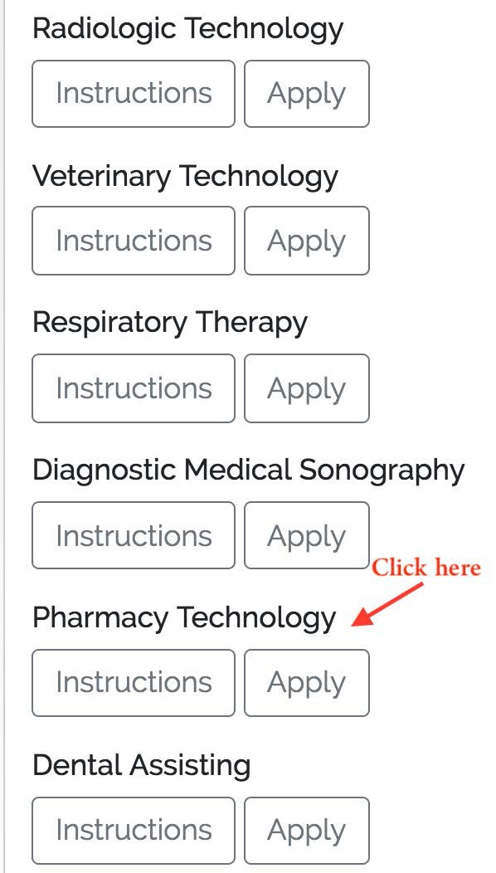

- Fill out and complete your Pharmacy Technician Application. Your application progress will be saved until the deadline, or until the program is filled – whichever comes first. You will
receive an email after you've begun your application, to the email displayed on your application.

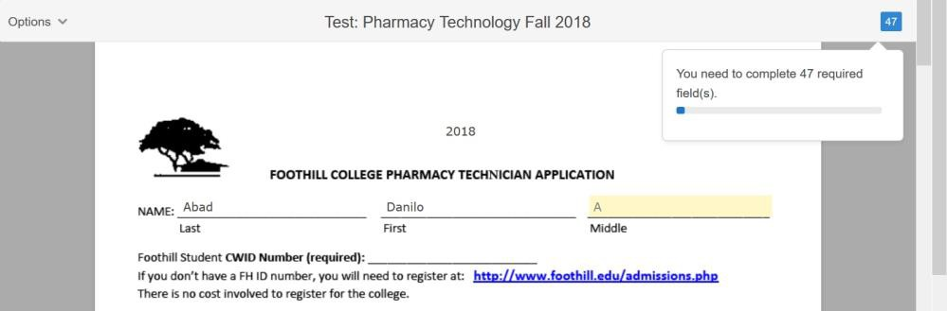

- Attach all documents by clicking on the designated boxes. After you click, you will be asked to choose from your saved files to upload.

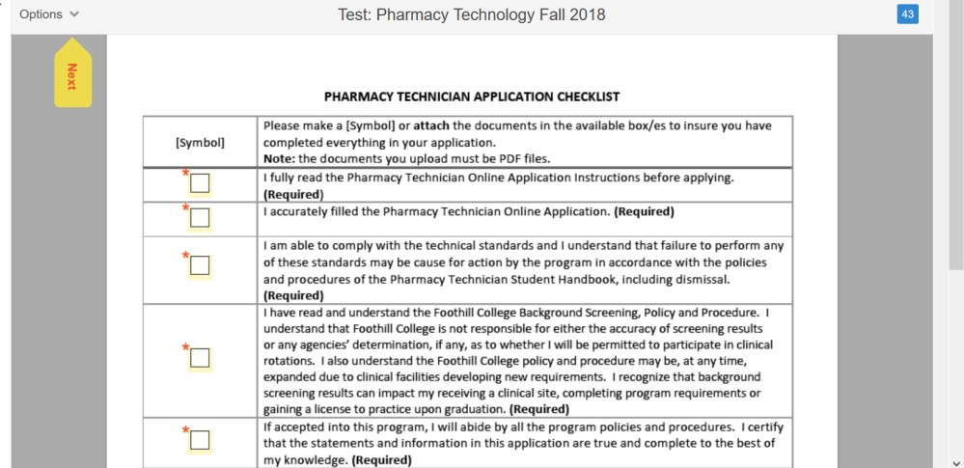

Submit your application

- When you are ready, submit your program application by signing it electronically. You will not be able to do this until you have filled all of the required sections. No changes will be allowed after you've signed the application.
Applicants may submit one Pharmacy Technician application per year.
IMPORTANT: Please make sure to review your application thoroughly for accuracy.

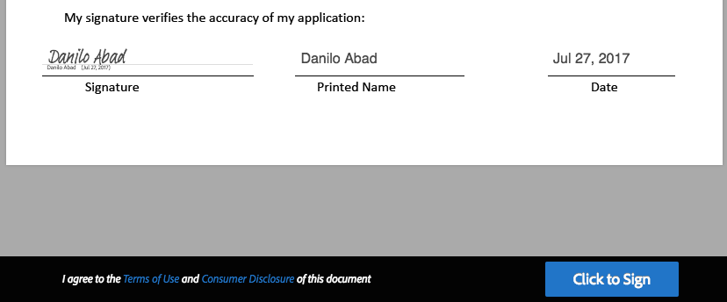

- You will be receiving an email confirming that you've successfully submitted your application, along with a copy of it, for your records. The email will be sent to the email linked to your MyPortal account, and displayed on the first page of the application.

Application Deadline: June 1 at 11:59pm PDT

If you have questions, please email:
healthcareerprograms@fhda.edu

or
Angela Su, Program Director at suangela@fhda.edu

