Foothill College
Credit Program Narrative
Certificate of Achievement in Basic Pharmacy Technician

Item 1. Program Goals and Objectives
What are the academic and vocational goals of this certificate? What are the general program objectives?

This short term, part-time, stackable certificate serves as a direct CTE pathway for high school and adult students to pursue careers within the pharmacy profession.

The academic curriculum, competency-based training, and transferrable skills development will result in skills and credentials necessary to secure living wage skilled positions in the pharmacy profession with the potential for promotion and opportunities for future educational advancement in pharmacy or any health-care related career.

It is a low barrier, part-time CTE pathway program which empowers students to achieve their goals as members of the health care workforce beginning in either high school or as an adult. The “stackable” series of certificates provides equitable educational and career advancement opportunities to ensure all California student populations reach their full potential while earning a living wage that can eventually lead to a high wage position.

The lower unit quarter course offering increases access and provides flexibility for students with financial and schedule limitations. The part-time aspect of this program is advantageous for adult students who would like a career change and are unable to participate in the full-time, 6-month Accredited Entry or Advanced Level Pharmacy Technician Program.

What knowledge and skills will students acquire as part of their participation in the program?

Students will acquire, develop, and strengthen essential transferrable skills required for effective collaboration between all health care professionals and for their success in the health care field. This includes communication, teamwork, ethics, professionalism, stress and time management, decision-making, building resilience, identifying learning strategies, demonstrating effective study skills, and goal setting—all essential for productive work habits and attitudes relevant in health care careers.
Students will acquire knowledge and demonstrate competency in the following disciplines; basic anatomy and physiology, medical terminology, pharmaceutical abbreviations, pharmaceutical preparations and medication names, pharmacy practice, pharmaceutical compounding, various drug formulations, complementary and alternative medicine, pharmaceutical calculations used in community practice, pharmacy law, HIPAA, pharmacology including diseases and medications used to treat conditions affecting body systems.

Students will complete 130 hours of clinical externship demonstrating and practicing their knowledge and skills acquired in a didactic/simulation setting. Competency will be evaluated by a preceptor at the site.

Students will participate in a comprehensive review of pharmacy technician technical and didactic competencies to prepare them for passing the national certification exams; either the Pharmacy Technician Certification Exam (PTCE) or ExCPT Exam. Students will complete the California Pharmacy Technician State License Application and register for either national board examination.

Item 2. Catalog Description
This should include program requirements, prerequisite skills or enrollment limitations, and information relevant to program goals.
Paragraph form program/course description:
This nine (9) month, part-time, stackable Basic Pharmacy Technician Program serves as a direct CTE pathway for students to pursue careers within the pharmacy profession and various entry-level allied health profession.

The academic curriculum, competency-based training, and transferrable skills development will result in skills and credentials necessary to secure living wage skilled positions in the pharmacy profession with the potential for promotion and opportunities for future educational advancement in pharmacy or any health-care related career.

Upon completion, students will receive a Certificate of Achievement as a Basic Pharmacy Technician.

Students must be 18 years old and possess a high school diploma/GED or equivalent to participate in externship and apply for a license with the California Board of Pharmacy.

Program Requirements: Any motivated student interested in the pharmacy profession or entering any health care career. Must be 18 years old and have a high school diploma/GED or equivalent.

Prerequisite skills: Satisfactory grades in Algebra 1, High School Biology, and English.

Enrollment Limitations: Based on the number of students the dual enrollment facility (off-site) can accommodate and Foothill College Lab/Classroom size. This is a cohort-based program with the ideal section size of 24 students.

Other information relevant to program goals: This section applies to students who obtain a Pharmacy Assistant (Aide) Certificate first through dual enrollment pathway and elect to participate in the stackable Basic Pharmacy Technician Certificate: Together, in partnership with the Boys and Girls Club of America and the Department of Veteran’s Affairs VITAL Program (VA Initiative in job Training Education And Learning), we proactively provide academic, basic needs, financial, technology, and additional learning support services to positively affect student success and retention. The academic curriculum and competency-based training will result in the skills and credentials necessary for the student’s placement into skilled positions within the VA or other Community Pharmacy positions with the potential for promotion and educational subsidies.

Item 3. Program Requirements

Update the table, below, to include all core and support courses for the program (note that support courses are called “Restricted Electives” by the state). In the Requirements column, list the total units for core courses and the total units for support courses. In the Sequence column, list the typical year and quarter during which the student will take the course. List the total units for the program requirements (core and support courses combined) beneath the table.

Requirements | Course # | Title | Units | Sequence
Core Courses  (# of units) | PHT 101 PHT 102 PHT 103  PHT 64A  PHT 63 | Pharmacy Careers A  Pharmacy Careers B  Pharmacy Careers C  Pharmacy Clinical Externship: 130 hours  Pharmacy Technician Certification Exam (PTCE) Review | 4  4  4  4  2 | 1 Fall quarter  1 Winter quarter  1 Win/Spring Qtr  1 Spring Quarter  1 Spring Quarter.
Restricted Electives  (# of units) | AHS 51  or  AHS 50A | Health Careers Exploration  or  Introduction to Allied Health Programs | 1.5  1.5 | 1 Fall quarter  1 Fall quarter
TOTAL UNITS: # of units =19.5 units
Update the list, below, to identify the number of units the student will likely take each quarter (program courses only).
Proposed Sequence:
Year 1, Fall = 5.5 units (AHS 51 or AHS 50A and PHT 101)
Year 1, Winter = 4 units (PHT 102)
Year 1, Winter/Spring = 4 units (PHT 103) (Term spanning)
Year 1, Spring/Early Summer= 6 units (PHT 64A and PHT 63)
TOTAL UNITS: 19.5 units

Dual Enrollment Pharmacy Assistant (Aide) “stackable” Basic Pharmacy Technician Certificate*
*additional 6 units only

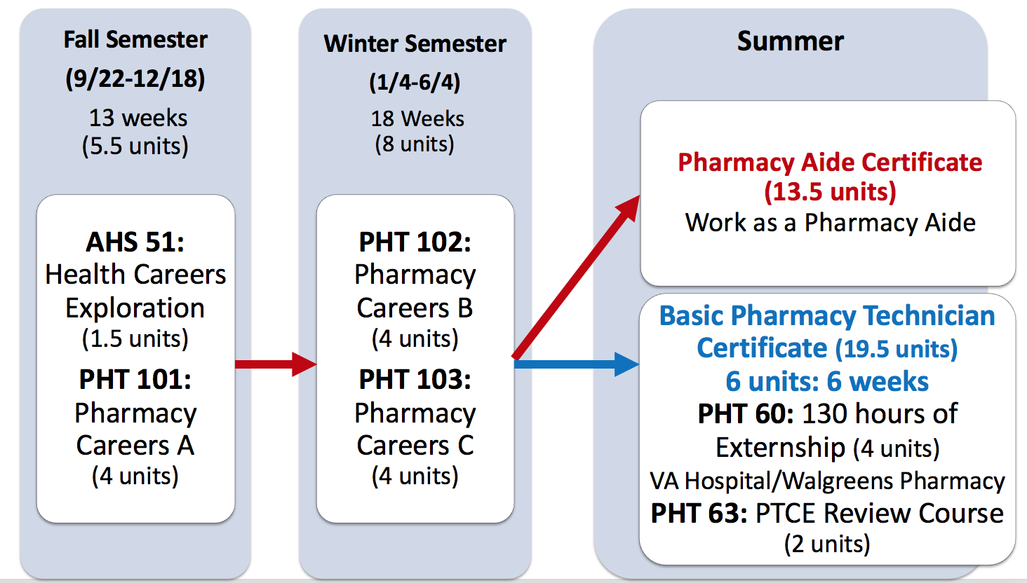

Part-time Basic Pharmacy Technician Program (Adult Student Cohort)

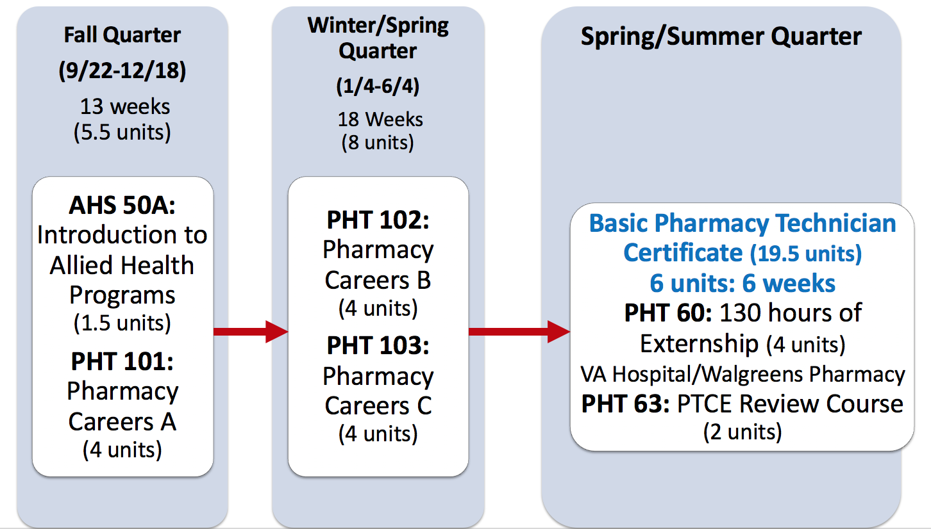

Item 4. Master Planning

How does the program align with the Foothill College Mission Statement? How does the program fit the curriculum and master planning of Foothill College, as well as higher education in California?

This part-time adult program aligns with Foothill’s Mission and Master Planning on multiple levels. It is a low barrier, part-time, CTE pathway program which empowers students to achieve their goals as members of the health care workforce beginning in high school through adulthood. The “stackable” series of certificates provides equitable educational and career advancement opportunities to ensure all California student populations reach their full potential all while earning a living wage that leads to a high wage position.

The Pharmacy Technology Department mission is guided by the same tenants of the college’s; honesty, integrity, trust, openness, transparency, forgiveness, and sustainability. We also foster five core teachings as student progress through the program; respect, unity, ownership, curiosity, and Ganas.

This innovative program fits the college’s strategy and focus on equity as it promotes direct and ease of access to educational and career exposure opportunities for all students. High School students who obtained a Pharmacy Assistant Certificate prior to continuing their education have extra support services through Foothill’s partnership with the Boys and Girls Club of America and the Department of Veteran’s Affairs VITAL Program (VA Initiative in job Training Education And Learning). Pharmacy Assistant Certificate recipients will continue to receive academic, basic needs, financial, technology, and additional learning support services to positively affect student success and retention while obtaining the Basic Pharmacy Technician Certificate. The collaboration of BGCP, VITALS, and the Foothill College PHT Program is a model of education and training for the next generation of Health Care workforce and leadership.

The academic curriculum and competency-based training will result in the skills and credentials necessary for the student’s placement into skilled positions within the VA or other Community Pharmacy positions with the potential for promotion and educational subsidies.

It also addresses the paucity of options for underserved, low income students by preparing them to work and advance professionally within the industry and/or pursue college at a later time. The flexibility and affordability of a part-time program increases student access. For the “adult student” the total cost for this certificate (tuition/books/student fees) is approximately $725.00 ($240.00 per quarter). For a “dual enrollment” student, the cost is only for 6 additional units plus student fees totaling $160.00.

Listed and highlighted below are the specific Educational Master Plan Goals this program addresses. It truly exemplifies Foothill College’s culture of innovation and problem solving, with the emphasis on eliminating disproportionate impact among student groups as it meets all but one goal:

Create a culture of equity that promotes student success, particularly for underserved students.
- Implement activities to improve achievement of student outcomes among those population groups experiencing disproportionate impact.
- Reduce barriers and facilitate students’ ease of access across the District and region.
- Enhance support for online quality and growth for instruction and student services.
- Collaborate with K-12, adult education and four-year institutions in ways that serve students and society.
- Partner with business and industry to prepare students for the workforce.

Strengthen a sense of community and commitment to the College’s mission; expand participation from all constituencies in shared governance.
- Encourage student participation in leadership and activities outside the classroom (including service/work-based learning) that engages students with the College and the community.
- Provide effective onboarding, support and professional development for all college employees.
- Encourage employee participation in leadership and activities that engages them with the College and the community.
- Promote consistent and clear communication in order to create a more informed, cohesive and engaged community.
- Increase lifelong learning opportunities for our community.
- Promote decision-making that respects the diverse needs of the entire college community.

Recognize and support a campus culture that values ongoing improvement and stewardship of resources.
- Increase advocacy at the state level, increase grants and private donations to secure stable and sustainable funding, and manage college resources strategically.
- Expand college practices and initiatives to support environmental stewardship.
- Employ data-driven decision-making.

Higher Education in California—Vision for Success:
SB 1070 and AB 288 emphasizes the development and strengthening of CTE pathways between high schools and community colleges to accomplish statewide objectives to meet under-served students in California. This new program meets several California’s Higher Education Vision for Success goals.

- This Basic Pharmacy Technician pathway program meets future workforce demand in California, as analyzed by the Centers of Excellence for Labor Market Research. It increases the number of students annually who will acquire specific skill sets, certificates, associate degrees, and credentials that prepare them for an in-demand job. This goal is consistent with the recommendations of the California Strategic Workforce Development Plan. The scope of education the students receives prepares them not only for careers in pharmacy, but serves as a foundation of knowledge applicable in all allied health professions.
- This program increases the percent of exiting CTE students who report being employed in their field of study; Pharmacy Careers. This dual enrollment/part-time program ensures students receive the training and education needed to be successful in the field of pharmacy. Upon program completion, they can directly work as entry-level Pharmacy Technician in a community pharmacy. This CTE pathway program prepares students for available jobs and supports students to find jobs in the pharmacy industry sector.
- This program reduces equity gaps across all of the above measures through faster improvements among traditionally underrepresented student groups. Through the partnership of the Boys and Girls Club of America, the Department of Veterans Affairs VITAL Program, dual enrollment pathway students will have extra resources and support to help them succeed both in and outside of the classroom. This collaboration is the first in the nation and we believe is the model that will truly serve underrepresented student groups.
- This program decreases the average number of units accumulated by students earning associate degree in Pharmacy Technology. The revised ASHP/ACPE Accredited Advanced Pharmacy Technician Training Program is 40 units instead of 52 units. Students who elect to obtain an AS Degree in Pharmacy Technology will only need to take their remaining GE requirements. This reduction of units-to-degree will help more students reach their educational goals sooner and at a lower cost.
- Because of COVID-19, California has increased the capacity and responsiveness of community colleges to address the skill development needs of employers and dislocated and unemployed workers, incumbent workers, and new entrants to the workforce. The goal is to offer individuals accelerated career pathways that enable them to gain skills and transition from unemployment to re-employment quickly. This short, part-time, training program provides the competency-based training and skills necessary for individuals to re-enter the workforce as capable and competent pharmacy technicians. Re-employment within the pharmacy industry will be immediate due to the high demand ad shortage of trained pharmacy technicians in the area. (See attached LMI report)

Item 5. Enrollment and Completer Projections
How many students are projected to complete the program after the initial year? After five years? List and explain the projections.

Initial year: 24 students are enrolled in first cohort and we anticipate 24 to successfully complete the Pharmacy Assistant (Aide) program. The realistic projected program completion goal is 80%;19 students. For students to continue with the Basic Pharmacy Technician Program, they must be 18 years old and have received their high school diploma/GED. While to goal is for all 19 students to continue to the Basic Pharmacy Technician Program, it will be dependent on how many students elect to immediately move forward with more education. We hope at least 10 of them will proceed with 6 more units of education to obtain their Basic Pharmacy Technician Certificate.

Because of COVID-19 limitations with instruction, we are offering this Part-Time Basic Pharmacy Technician Training Program for the 2020-21 academic year instead of our Advanced Pharmacy Technician Program. This initial year, we project 15 adult students to complete the program. With the estimate of at least 10 dual enrollment students and 15 adult students, we will have 25 students (or more) complete the Basic Pharmacy Technician Program. The course sequencing is almost identical for the Adult Cohort and Dual Enrollment Cohort. The difference is in the “support course” (restrictive electives).
Adult students who applied the Pharmacy Technician Program have taken PHT200L, the prerequisite for our program and have confirmed Pharmacy Technology as their choice profession so AHS 51 Health Careers Exploration unnecessary. Instead, the adult student cohort will take AHS 50A: Introduction to Allied Health Programs. Both courses, AHS 50A and AHS 51 are 1.5 units and provide similar essential training and content needed for success in the health care profession. Note the AHS 50A course for the Adult Cohort Curriculum below.

Part-time Basic Pharmacy Technician Program (Adult Cohort)

The college can offer the Part-time Basic Pharmacy Technician Program to adult students limited to 24 students per section.

Since this is a cohort-based program, total enrollment will be dependent on regional high school districts offering this program to their students. The goal is to expand this program to surrounding high school regions; San Jose, East Bay, etc.

After 5 years, an increase in the number of regions that offers this cohort program will increase the number of total enrolled students by a factor of 24. Example: If there are 2 cohorts per year (Redwood City and San Jose School districts), we will have 48 enrolled students.

The total enrollment including both the Adult student Section and Dual Enrollment Student Section could be 48 students or more.

Additionally, update the table, below, to include all courses for the program (core and support), and provide historical enrollment data from the past two years. Foothill’s Institutional Research department can help provide this data; visit their website to submit a request. If a course is new or has not been offered in the past two years, enter N/A for the annual sections and annual enrollment.

 |  | Year 1 |  | Year 2
Course # | Course Title | Annual Sections | Annual Enrollment | Annual Sections | Annual  Enrollment
AHS 51 | Health Careers Exploration | 1 | 29 | 1 | 34
AHS 50A | Orientation to Health Care Careers | 6 | 166 | 7 | 180
PHT 101 | Pharmacy Careers A | N/A | N/A | N/A | N/A
PHT 102 | Pharmacy Careers B | N/A | N/A | N/A | N/A
PHT 103 | Pharmacy Careers C | N/A | N/A | N/A | N/A
PHT 64A (Formerly PHT 60) | Pharmacy Clinical Externship A | 1 | 26 | 1 | 17
PHT 63 | PTCE Review Course | 1 | 26 | 1 | 17

Item 6. Place of Program in Curriculum/Similar Programs

How does the program fit in Foothill College’s existing program inventory?

Foothill College does not have a CTE stackable pharmacy pathway program with training beginning from high school nor a part-time Basic Pharmacy Technician Program. This new program increases access for both high school and adult students:
High school students simultaneously obtain high school elective units and a certificate upon completion. They can choose to either enter the pharmacy workforce as a Pharmacy Assistant (Aide), or elect to continue their education with 6 additional units of course work (including 130 hours of externship) to obtain their Basic Pharmacy Technician Certificate* (stackable certificate).
Adult students now have access to a part-time program which is advantageous for individuals who are unable to participate in the full-time Entry-Level/Advanced Level Pharmacy Technician Program.

All students are eligible to apply for a Pharmacy Technician license with the California Board of Pharmacy. After working for an additional 370 hours as a Pharmacy Technician, they qualify to take the National Pharmacy Technician Certification Exam (PTCE) to become a “Certified Pharmacy Technician”.

Students can continue on the pathway to complete “Advanced Pharmacy Technician Training Program” and take additional GE courses to obtain an Associate’s Degree in Pharmacy Technology. Finally, if students wish to become a Pharmacist, they can take all required pharmacy school pre-requisites offered at Foothill College without having to attend a 4-year college/university. There are no other programs at Foothill College with pathway beginning in high school that provides students numerous career and education opportunities within the pharmacy/health care profession.

The Complete Pharmacy Careers CTE Pathway:
Pharmacy Aide ⇒ Basic or Entry Level Pharmacy Technician ⇒ Certified Pharmacy Technician ⇒ Advanced Level Pharmacy Technician ⇒ AS Degree in Pharmacy Technology ⇒ PharmD (Doctor of Pharmacy)

*students must be 18 years old and possess a high school diploma/GED or equivalence to complete externship and California Board of Pharmacy licensing requirements.

Item 7. Similar Programs at Other Colleges in Service Area

Are there other programs similar to this one already in place offered in Foothill’s service area?

No, Foothill is the only community college that offers a pharmacy technology program in our service area — “Silicon Valley Sub-Region” issuing 33 awards on average annually (last 3 years) on this TOP code.
However, there are two (2) community colleges in the “Bay Region” issuing 73 awards on average annually (last 3 years ending 2018-19) in San Francisco (Mid-Peninsula) and Santa Rosa (North Bay).
There are six (6) other Educational Institutions in the “Bay Region” issuing 131 awards on average annually (last 3 years ending 2016-17) on TOP 1221.00-Pharmacy Technology. There is one other Educational Institution issuing 16 awards on average annually (last 3 years) on this TOP code.

None of these other Educational Institutions are located in Foothill’s service area. Most importantly, there are no dual enrollment pathway programs that begin with the Pharmacy Assistant/aide certificate and allow for students to attain a stackable part-time Basic Pharmacy Technician Certificate within Foothill College’s service area.

Note: Mission College offers a Pharmacy Technician Training Program through Adult Education.

Please see LMI Charts below on Educational Supply
Table 7a. Awards on TOP 1221.00-Pharmacy Technology in Bay Region
College | Sub-Region | Associates | Certificate Low Unit | Total
Foothill | Silicon Valley | 15 | 18 | 33
San Francisco | Mid-Peninsula |  | 19 | 19
Santa Rosa | North Bay | 6 | 15 | 21
Total Bay Region |  | 21 | 52 | 73
Total Silicon Valley Sub-Region |  | 15 | 18 | 33

Source: Data Mart
Note: The annual average for awards is 2016-17 to 2018-19.

Table 7b. Other Educational Institutions Awards on TOP 1221.00-Pharmacy Technology in Bay Region
College | Sub-Region | Award < 1 academic yr | Award 1 < 2 academic yrs | Award 2 < 4 academic yrs | Total
Bay Area Medical Academy | Mid-Peninsula |  |  | 11 | 11
Carrington College-Pleasant Hill | East Bay | 17 | 5 |  | 22
Carrington College-San Jose | Silicon Valley | 11 | 5 |  | 16
Carrington College-San Leandro | East Bay | 11 | 4 |  | 15
InterCoast Colleges-Fairfield | North Bay |  |  | 15 | 15
Unitek College | East Bay |  | 52 |  | 52
Total Bay Region |  | 39 | 66 | 26 | 131
Total Silicon Valley Sub-Region |  | 11 | 5 |  | 16

Source: Data Mart
Note: The annual average for awards is 2014-15 to 2016-17.

Is the program similar to successful programs outside of the service area?
Yes/No: Yes AND No:
Yes, there are other programs that offer Pharmacy Technology training. Please see above. Unitek College has recently discontinued their Pharmacy Technology Program.
No, there are no dual enrollment pathway programs that begin with the Pharmacy Assistant/aide certificate and allows for students to attain a stackable part time Basic Pharmacy Technician Certificate within Foothill College’s service area.

Additional Information Required for State Submission:

TOP Code: If you are unsure about the TOP code for your particular program please contact the AVP of Instruction

TOP 1221.00- Teresa will verify Pharmacy Technology in the state and region.
Pharmacy Technicians (SOC 29-2052):

Annual Completers: Anticipate 25 students the first year (15 adult college cohort and 10 dual enrollment cohort students). The goal is to increase number of cohorts offered at various high school regions. An increase in the number of regions that offers this cohort program will increase the number of enrolled students by a factor of 24. Example: If there are 2 cohorts per year (Redwood City and San Jose), we will have 48 enrolled students etc.

Net Annual Labor Demand: The Employment Outlook Labor Demand Table indicates an increase in the number of jobs by 5% over the period of 5 year for Pharmacy Technicians. Please review attached LMI report data
Based on the data included in this report, there is a labor market gap in the Bay region with 983 annual openings for the Pharmacy Aide/Pharmacy Technician occupational cluster and 205 annual (3-year average) awards for an annual undersupply of 778 students. In the Silicon Valley Sub-Region, there is also a gap with 210 annual openings and 49 annual (3-year average) awards for an annual undersupply of 161 students.

Occupational Demand
Table 1. Employment Outlook for Pharmacy Aide Occupations in Bay Region
Occupation | 2019 Jobs | 2024 Jobs | 5-Yr Change | 5-Yr % Change | 5-Yr Open-ings | Average Annual Open-ings | 25% Hourly Wage | Median Hourly Wage
Pharmacy Aides | 1,945 | 1,820 | -125 | -6% | 1,201 | 240 | $13.39 | $17.20
Pharmacy Technicians | 8,026 | 8,409 | 383 | 5% | 3,714 | 743 | $17.43 | $21.81
TOTAL | 9,971 | 10,229 | 259 | 3% | 4,915 | 983 | $16.64 | $20.91
Source: EMSI 2020.1
Bay Region includes Alameda, Contra Costa, Marin, Monterey, Napa, San Benito, San Francisco, San Mateo, Santa Clara, Santa Cruz, Solano and Sonoma Counties
Table 2. Employment Outlook for Pharmacy Aide Occupations in Silicon Valley Sub-Region
Occupation | 2019 Jobs | 2024 Jobs | 5-Yr Change | 5-Yr % Change | 5-Yr Open-ings | Average Annual Open-ings | 25% Hourly Wage | Median Hourly Wage
Pharmacy Aides | 354 | 316 | -37 | -11% | 214 | 43 | $12.40 | $14.13
Pharmacy Technicians | 1,931 | 1,977 | 46 | 2% | 836 | 167 | $15.03 | $18.76
TOTAL | 2,285 | 2,294 | 9 | 0% | 1,049 | 210 | $14.63 | $18.04
Source: EMSI 2020.1
Silicon Valley Sub-Region includes Santa Clara Count

Job Postings in Bay Region and Silicon Valley Sub-Region
Table 3. Number of Job Postings by Occupation for latest 12 months (June 2019 - May 2020)
Occupation | Bay Region | Silicon Valley
Pharmacy Technicians | 3,256 | 565
Pharmacy Aides | 348 | 72
TOTAL | 3,604 | 637
Source: Burning Glass
Faculty Workload: PT course load is 0.305

New Faculty Positions: 1 Part-Time instructor

New Equipment: Textbooks, Materials, Supplies, Consumable workbooks for 24 dual enrollment students students=$5000. Adults students: Software

New/Remodeled Facilities: $0.00 (dual enrollment off-site at Boys & Girls Club of the Peninsula). Use current PHT lab classroom for Adult Student Cohort at Foothill College which accommodates 24 students.

Library Acquisitions: $0.00

Gainful Employment: Indicate if Yes or No: Yes

Program Review Date: Indicate the month and year of the first Program Review (recent CPR)
Pharmacy Technology Comprehensive Program Review Academic Year 2019-2020 (Submitted December 2019. Because of COVID-19 Shelter in Place, the college will finalize CPR results and findings Fall 2020)
Distance Education: This is the percentage of program courses conducted online; choose from the following: 0% 1-49% 50-99% 100%

0% of the program is intended to be conducted online.

Please note that significant lead time (one month or longer) may be necessary to obtain the following documents/approvals. Please work with the AVP of Instruction during the beginning stages of program creation to submit your requests for the following:

ATTACH THE FOLLOWING (non-Apprenticeship):
- Labor Market Information and Analysis
Please request LMI from the Center of Excellence, as this specific report is required for your submission to the BACCC (regional consortium). You will need to know the SOC (Standard Occupational Classification) code to use for your program; for help determining this code, and for any other questions about requesting LMI, please contact the AVP of Workforce and CTE Programs
- Advisory Committee Recommendation (includes advisory committee membership, minutes, and summary of recommendations)
- Regional Consortia Approval Meeting Minutes (showing program recommendation)

ATTACH THE FOLLOWING (Apprenticeship only):
- Labor Market Information and Analysis
- Approval Letter from the California Division of Apprenticeship Standards (DAS)

