CREATING LINKS TO SHARED DOCUMENTS 2/12/18

You’ll need to upload the documents in order to link to them. There are two ways to do this.

BEFORE YOU START
- Consider your audience. Will they have the software to open the file? We recommend converting Word, Excel and PPT documents to PDF format when linking from a web page.
- Prepare the files for upload beforehand so that you know where they are on your computer.
- The file names should be lower case, with no spaces. Note: You can rename the files after uploading to OU Campus.

UPLOADING MULTIPLE DOCUMENTS TO OU CAMPUS
- LOG IN to OU Campus.
- CLICK the Content Tab.
- NAVIGATE TO FOLDER where you manage PDF files (usually PDF folder). Consider if there is a a subfolder, such as academic year for governance committees or other categories.
- CLICK Upload button.
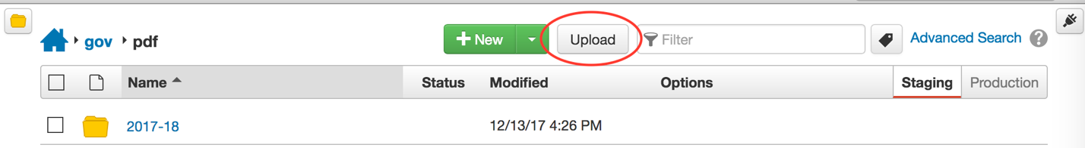

- DRAG files from desktop or CLICK ADD to find the files on your desktop to select for upload. Note: RENAME the files to eliminate any spaces or other bad characters. We recommend using hyphens (-) ONLY to separate words. Be sure to include the .pdf, .docx or .pptx file extension if renaming.
- CLICK Start Upload (blue button at bottom right) Note: You will be prompted that the upload was successful when done. You must now publish the files uploaded!
- CLICK the Check Box for each file(s) just uploaded and select PUBLISH.
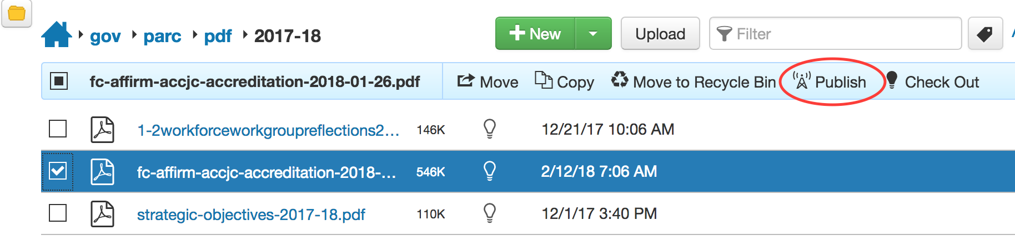
- NAVIGATE back to the page where you want to create a link to the newly uploaded file(s) and follow steps for ADDING A LINK.

