DIAGNOSTIC MEDICAL SONOGRAPHY PROGRAM
APPLICATION INSTRUCTIONS

Application Deadline: 04/01/2026 at 11:59 PM PDT

The Diagnostic Medical Sonography application will be available online. Please take time to review all instructions carefully to ensure your application is complete and submitted by the deadline.
Follow the steps below to complete and submit your Diagnostic Medical Sonography application:
Before you apply
- Visit the Diagnostic Medical Sonography website and read all available information.
Diagnostic Medical Sonography Program Website Click Here

- Obtain a Campus Wide Identification Number (CWID) to apply for the Diagnostic Medical Sonography Program. You can get a CWID at no cost by applying to Foothill College. For full details, please check Foothill College’s Registration Website.
Foothill College’s Registration Website Click Here
Application Requirements
- Confirm Eligibility: Review the program prerequisites and sample application to ensure you are ready and eligible.
- Program Prerequisites Click Here
- Sample Application Click Here
- Calculate GPA: Use the online tool to calculate your cumulative GPA: https://foothill.edu/counseling/gpacalc.html
- Gather Documents: Obtain and prepare copies of the required documents.
    - Required Documents:
      - Official Electronic Transcripts (e-transcripts) from ALL colleges attended, except for Foothill and De Anza Colleges.
      - Completed and signed Patient Care Experience Form (DPCE).
    - Additional Documents: The following documents are optional. Please include them only if they are applicable.
      - A copy of your American Heart Association BLS (CPR) Card
      - Copy of a completed General Education (GE) Pattern: Cal-GETC, CSU, IGETC, or Local Foothill College GE.
      - Copy of Degree Works that shows completed GE requirements
Transcripts
Returning applicants do not need to resubmit official transcripts unless they have completed new coursework that will affect their cumulative GPA.
Official Foothill College and/or De Anza College transcripts are not required. If you have prerequisite coursework completed from Foothill College or De Anza College, you must enter the coursework where appropriate on the application. We can verify your successful completion of that coursework internally.
Official college transcripts are required from all colleges you attended. Request transcripts from the Registrar or Registration office at each institution. Transcripts must be sent directly to Foothill College Admissions and Records via Official Electronic Transcripts (e-transcripts).
If your school doesn't offer this option, please send them to:
Admissions and Records
DMS – Health Sciences
Foothill College
12345 El Monte Road,
Los Altos Hills, CA 94022

If you hold an Associate's Degree from a California Community College or a Bachelor's Degree from a UC or CSU, your General Education requirements are automatically waived.
If you are unable to obtain any of the required documents, you must provide a letter of explanation to be attached to your application.
Please review our Diagnostic Medical Sonography Sample Application. Since this sample closely mirrors the actual application, you can use it to see exactly what information you will need to submit when you apply. We encourage you to fill out the sample to prepare.
Scanning and Saving Required and Optional Documents
- Before applying, create a dedicated folder on your computer for all required documents.

Important File Requirement: Each required section allows for only one file attachment. Therefore, if you have multiple items for one section, you must combine them into a single file (e.g., one PDF) for upload.

For help with combining multiple files into one, visit Foothill College’s ASFC Smart Shop.
ASFC Smart Shop Click Here

Proceed to the Application
- Begin your Diagnostic Medical Sonography program application by visiting the MyPortal site:
My Portal Click Here

- Log in to My Portal.

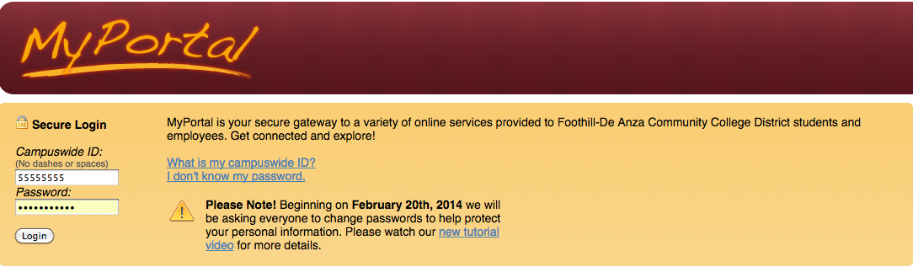

- Click on the VIEW ALL CARDS located in the upper right-hand corner.
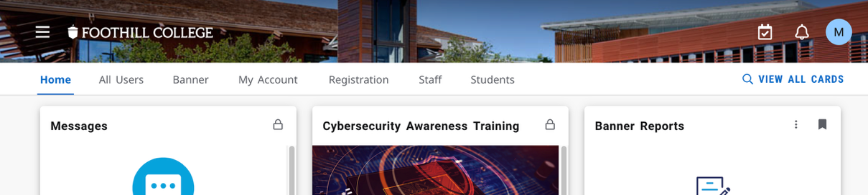

- Click on the Allied Health Card.
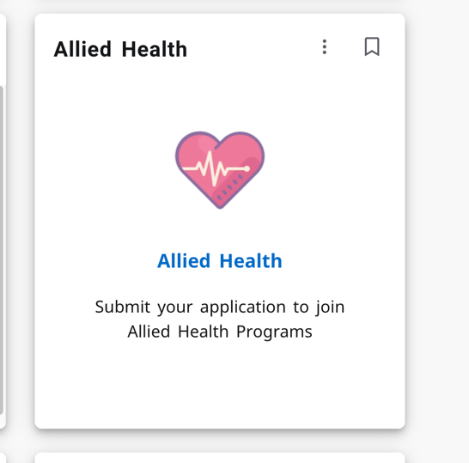
- Click on the Apply button


- Fill out and submit your application. Note that your progress will be saved automatically until the deadline. After you begin, we’ll send you a confirmation email to the address listed on your application.

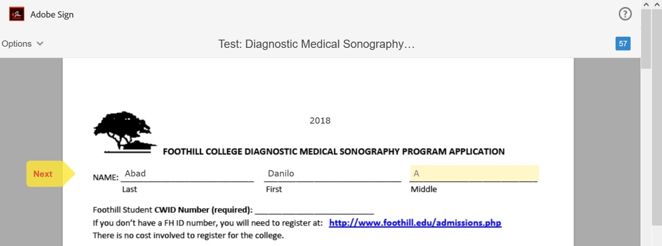

- Attach the Patient Care Experience by clicking on the designated boxes. After you click, you will be asked to choose from your saved files to upload.

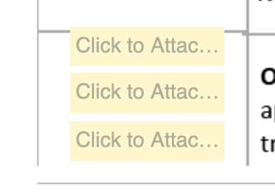

Submit your application
- Once all required sections are complete, you can electronically sign and submit your application. Since no changes are permitted after signing, please ensure you thoroughly review your application for accuracy before you submit. Remember, you are limited to one Diagnostic Medical Sonography application per year.

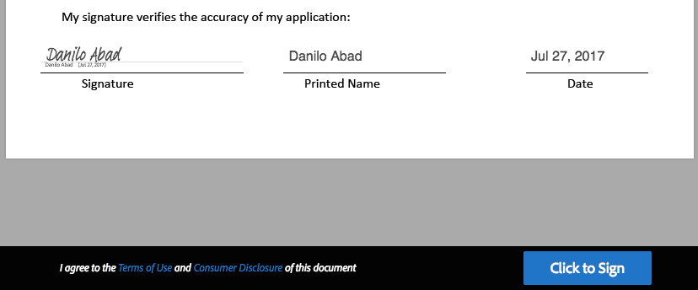

- You will receive an email confirming that you've successfully submitted your application, along with a copy for your records. The email will be sent to the email linked to your MyPortal account and displayed on the first page of the application.

Program application deadline: 04/01/2026 at 11:59 pm PDT

If you have questions, don't hesitate to get in touch with the Health Science and Horticulture Division Office at healthcareerprograms@fhda.edu

